FITTING INSTRUCTIONS FOR FP0018BK FORK PROTECTORS

HONDA CRF 250/450 ’02-’04 / CRX 250 ‘04
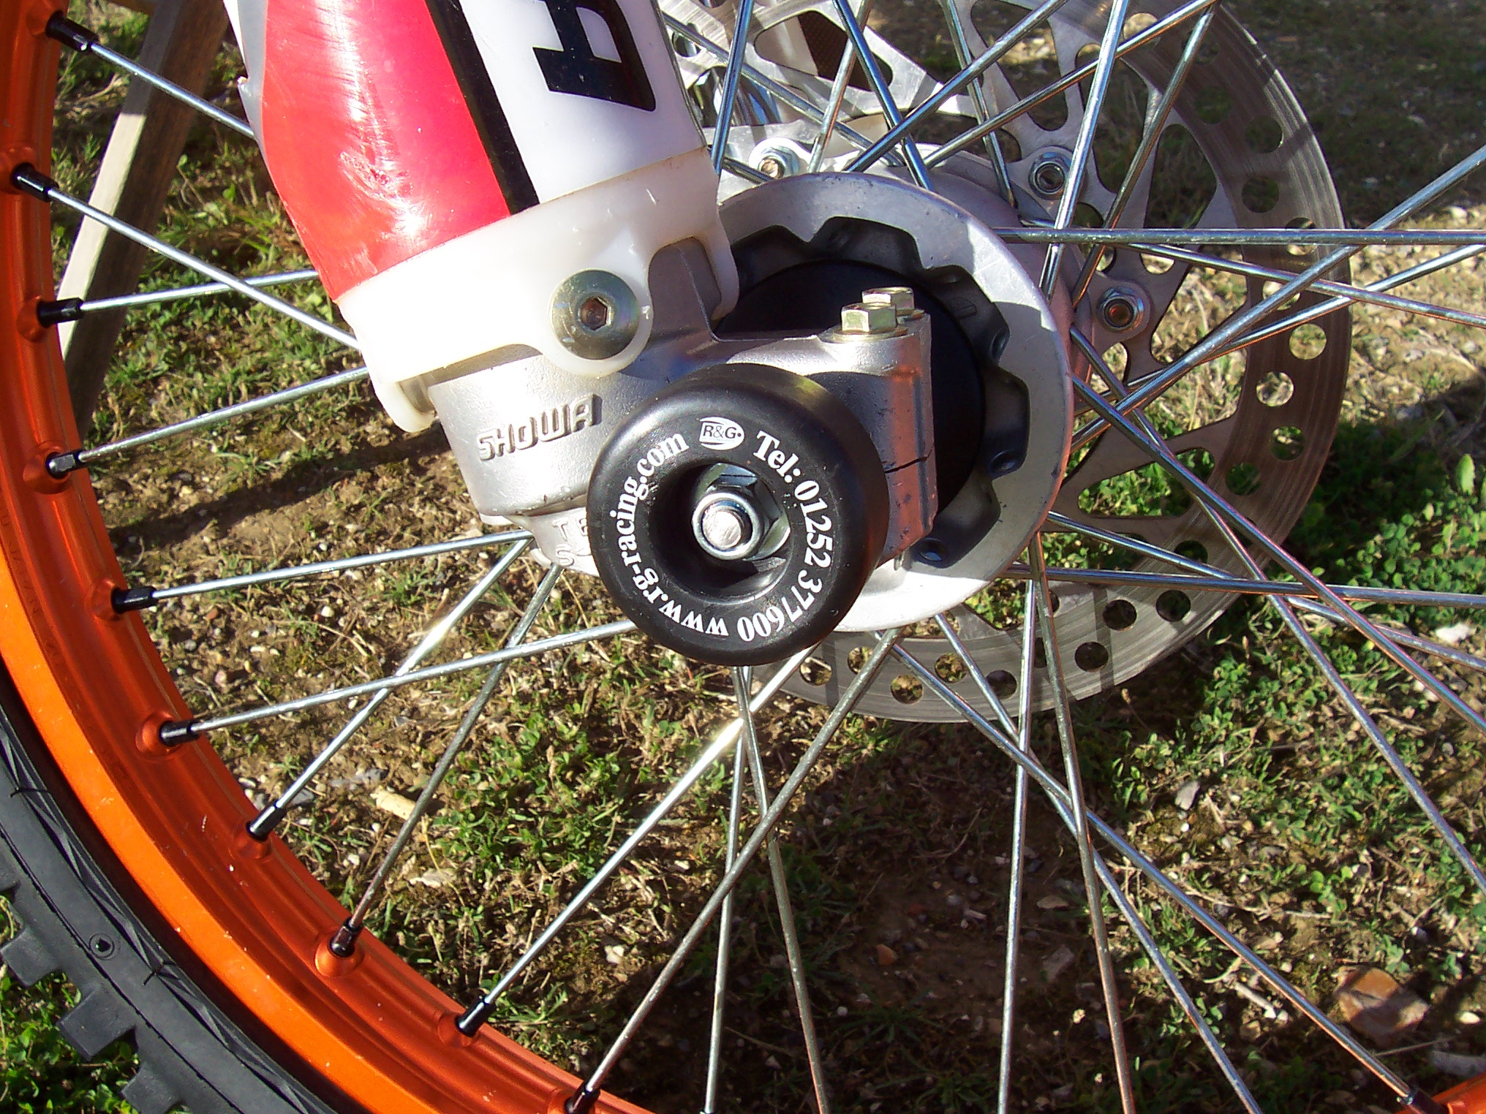

Please note that the way the kit is packed does not necessarily represent the way of mounting to the bike

- Fit spacer into hex end of front wheel spindle (throttle side)
- Loosely fit one of the nuts to one end of spindle bar
- Slide one of the washers up behind the nut
- Slide protector with the longer neck up to nut
- Place assembly through the spacer that you already fitted, & push through the hollow spindle
- Place other protector over exposed end of spindle bar
- Fit remaining washer and nut to end of spindle bar
- With a socket on either end, tighten until the assembly locks into place
- Do not overtighten – the nyloc nuts will hold it tight.

CONSUMER NOTICE
The catalogue description and any exhibition of samples are only broad indications of the Products and R&G may make design changes which do not diminish their performance or visual appeal and supplying them in such state shall conform to the order.
The Buyer acknowledges no representation or warranty (other than as to title) has been given or will apply to the Products other than those in R&G’s order or confirmation and the Buyer confirms it has chosen the Products as being of merchantable quality and suitable for its particular purposes.
Where R&G fits the Products or undertakes other services it shall exercise reasonable skill and care and rectify any fault free of charge unless the workmanship has been disturbed. The Buyer is responsible for ensuring that the warranty on the motorcycle is not affected by the fitting of the Products.
On return of any defective Products R&G shall at its option either supply a replacement or refund the purchase money but shall not be liable if the Products have been modified or used or maintained otherwise than in accordance with R&G’s or manufacturer’s instructions and good engineering practice or if the defect arises from accident or neglect.
Other than identified above and subject to R&G not limiting its liability for causing death and personal injury, it shall not be liable for indirect or consequential loss and otherwise its liability shall be limited to the amounts paid by the Buyer for the Products or the fitting or service concerned.
These terms do not affect the Buyer’s statutory rights.

R&G RACING RETURNS POLICY (NON-FAULTY GOODS)
Returns must be pre-authorised (if not pre-authorised the return will be rejected)
Goods may only be returned direct to us if they were purchased direct from us (customer must prove if necessary). Otherwise to be returned to original vendor.
Goods must be in re-sellable condition, in the opinion of R&G Racing.
All returns are subject to a 25% restocking and handling fee (25% of the gross value exc. P&P – at the prevailing price at time of purchase).
The customer must pay any and all carriage charges.
No returns of discontinued products, unless within 14 days of purchase.
This policy does not affect your statutory rights and does not refer to faulty goods.

