Operation Manual

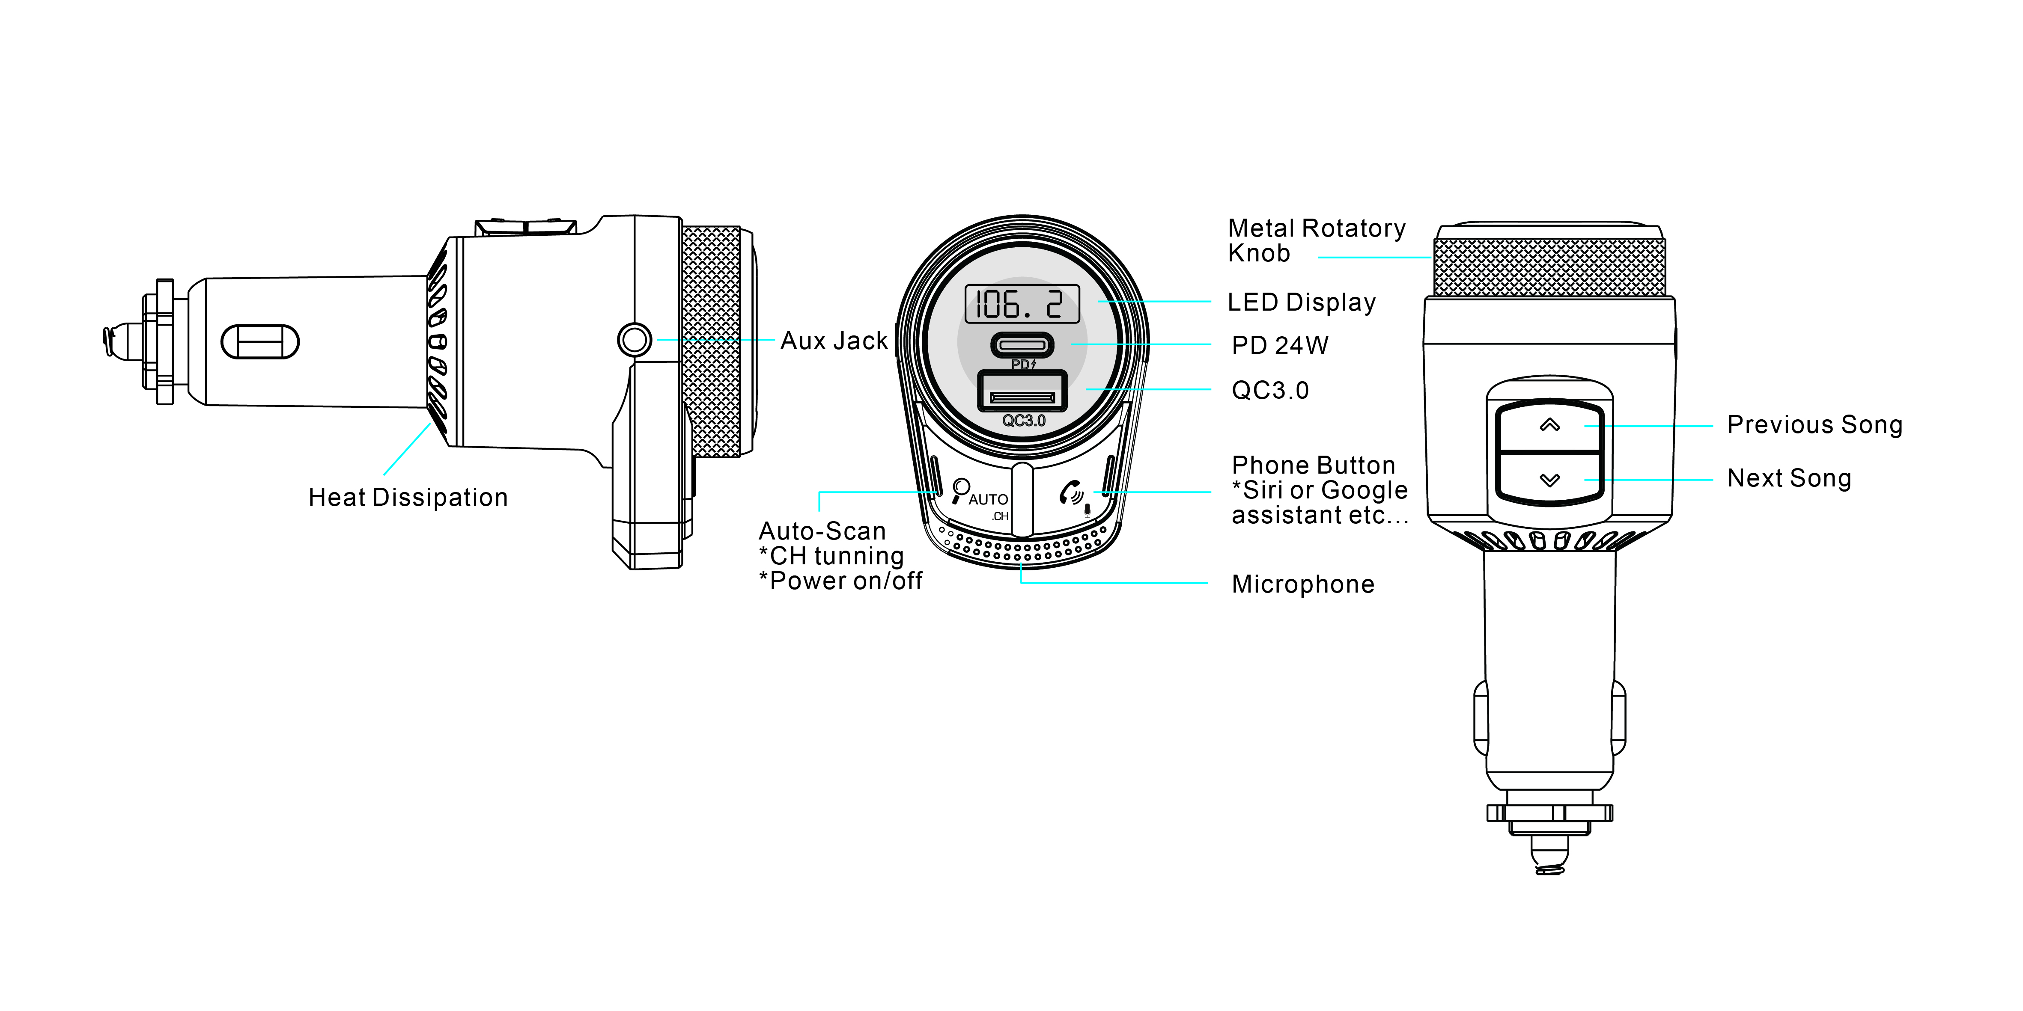
Installing the Product:
- Plug it into the power socket
- The LED display shows the voltage of the car battery first for a few seconds and then shows "bt" to indicate Bluetooth pairing mode is successful.

Bluetooth Pairing:
- When the LED display shows "bt" and the device will enter into Bluetooth pairing mode.
- Enable Bluetooth on the device you want to pair.
- Search and select "BFU38" from the list, then connect.
- Enter the pairing code ‘0000’ or ‘1234’ If asked

Connect to FM Radio | Auto-Scan mode
- Press the ‘AUTO’ button to start auto-searching. The LED will show the FM frequency from the current station to the next station in order. Until it detects the best available station nearby, it will stay on this detected station.
- Tune your car radio to match the same frequency.
- If the first detected station is not an ideal one, press the ‘AUTO’ button again to auto-search the next available FM frequency.

Connect to FM Radio | Manual mode
- Tune your car radio to an unused FM frequency.
- Double press the ‘AUTO’ button to enter manual tuning mode.
- Tune the rotary knob on this device to match the same frequency.

Playing and Controlling the Music
- Play music directly from the mobile device that is connected to the BFU38 via Bluetooth.
- Press the Phone button to play or pause music.
- Press the buttons on the back of BFU38 to the previous song or skip to the next song.
- Tune the rotary knob clockwise or anticlockwise to increase or decrease volume.

Tip: The product will automatically switch to the phone call if receive a call while playing music

Making Phone Calls
- Press  to answer the incoming call. Press and hold to reject the call.
- Press  to hang off a call.
- Press twice to dial the last Phone Number automatically.
- During a call, press and hold  to switch to a private conversation.
- You can only dial the phone number by your mobile phone when making a call, you can use the hands-free function to enjoy it once the call is connected

Activating Voice Assistant
- Press and hold the phone button to activate voice assistant on your mobile phone (Siri or Google Assistant etc...) when in Bluetooth mode
Line-out Function

Use the supplied AUX cable to connect this device & the aux jack on your car head unit while Bluetooth is connected.
Bluetooth Pairing
Charging Mobile Devices
- To connect your Smart device with a USB cable (not included) to one of the two USB charging ports (USB & PD) for charging
- Voltage outputs: PD 20W & QC3.0 18W

Switch ON/OFF
- Press and hold the ‘AUTO’ button for 2 seconds to turn off FM/display/Bluetooth function on the product, only keeping the charging mode.
- Press and hold the ‘AUTO’ button for 2 seconds again to turn on.

Precautions
Please read all safety instruction warnings carefully before using this product. Improper use of this product may result in damage to this product or attached devices. To ensure the products work well, please never use this device in the following :
- Moist or underwater conditions;
- Conditions near a heater or high-temperature sources;
- Conditions with direct and strong sunshine;
- Conditions with attempted falling;
- Never dismantle the product without permission, otherwise, it may nullify the warranty clause.

END

