Dear customer,

We recommend that you select from Wigs234.com. However, if the products do not meet your needs, we can also customize wigs according to your requirements. You need to provide detailed information about the wig. Our customer service staff will confirm with you about your needs and the price we offer, by email .

We will try our best to meet your needs. While please kindly note that, for some wigs we may be unable to produce, due to the hairstyle or color reason. Customer service staff will contact you within 3 working days.

Tell us the detailed description about the wig you want. Please tick √ in the box and fill in the blanks, Or mark your options in red.

|  |
| --- |
| 1. Human Hair  Synthetic Hair |
| 1. Large  Average  Petite |
| Custom Size （Only for human hair wigs）  How to measure?  QQ截图20190307150402   * Circumference (inch) : * Forehead to Nape of Neck (inch) : * Ear to Ear across Front Hairline (inch) : * Ear to Ear over the Top (inch) : * Temple to Temple around Back (inch) : * Nape of Neck (inch) : |
| 1. Capless  Lace Front  Full Lace （Only for human hair wigs）  Mono Top |
| 1. Hair Color     Synthetic Wigs color： |
| Human Hair Wigs color： |
| 5. Please leave your name and contact information(required)  *Your Name:  *Country:  *Tel:  *Email: |
| 6. If you have any additional requirements, please leave your message here: |

7. Attach pictures or celebrity hairstyle photos here, or send files to our email box as an attachment:

Picture 1: Front

Picture 2: Back

Picture 3: Left Side

Picture 4: Right Side

Sample:

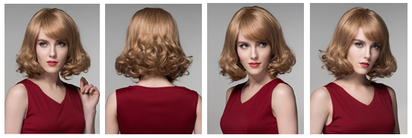

Production Duration:

|  |  |  |  |  |  |  |  |
| --- | --- | --- | --- | --- | --- | --- | --- |
| Material | Synthetic | | | Human Hair | | | |
| Cap | capless | lace front | mono top | capless | lace front | full lace | mono top |
| Processing Time | 4-11 Days | 7-15 Days | 15-25 Days | 7-15 Days | 10-21 Days | 20-30 Days | 15-25 Days |
| Shipping Time | **2-8 Days DHL** | | | | | | |

**Please kindly notice that we charge extra fees for custom costs:**

**$20 for human hair wig**

**$10 for synthetic hair wig**

**Please ensure that the above information is completed correctly.**

**Attach this customization form and the wig photos.**

**Email us at: service@wigs234.com**