INSTALLATION GUIDELINES
Product Information - PLEASE READ BEFORE INSTALLATION!

Note: By installing MBA flooring, you acknowledge that you have read through and understand all of the topics covered in this document, including the warranty information and care.

Storage and Handling:

- Remove flooring from your vehicle immediately after transporting it to the job site.
- MBA Grande must be acclimatized prior to installation. Store flat and fully supported during shipping and storage. Do not store or stack the boxes sideways or on the edge, this will compromise the locking system.
- Climatize package in the room where installation is to take place with a constant temperature of 65°F to 85°F (18° to 29°C) for a period of 48 hours prior to installation.

Installer Responsibilities:

- Inspect MBA Grande for possible defects prior to installation. Complaints can only be accepted before installation. Slight variations in color and texture are designed to enhance the finished product. Mixing the planks creates a more natural appearance. MBA Grande replicates the look of natural products, showing natural variation in color, texture, and gloss. For optimal visual effect, mix planks or tiles by working from several cartons. Blend tiles into the installation, avoiding the placement of similar decors next to one another.
- Ensure you have the correct quantity on hand.
- DO NOT install damaged flooring.
- Be aware that when exposed to excessive temperatures and direct sunlight the MBA Grande may expand and contract causing problems with the locking system using a floating installation. Window coverings should be installed to avoid prolonged sunlight exposure. Please consider sun/heat exposure when deciding if the site
will require a glue down installation. MBA Grande is a floating floor installation only; therefore, a different product would need to be specified for glue down installations.
- If the MBA Grande is being installed in facilities where walkers, wheelchairs are present, or in facilities with movement of heavy displays, racks, dentist chairs patient beds, etc. These types of installations may exert extreme stress and compromise the locking system. Therefore, we do not recommend installation of our MBA Grande Click Vinyl on those areas. Perhaps Dry Back Glue down Vinyl can be used for heavy traffic offices rather than our MBA Grande Click Vinyl.
- Determine if there is a need for noise reduction required above our tested STC and IIC sound ratings. Many residential applications such as condos and senior living facilities require noise suppression between floors. If the building requires extra sound ratings above our tested sound ratings, MBA Grande recommends using an approved acoustic underlay. Approved underlayment - 1 mm IXPE. However, the subfloor (Plywood and concrete) must be flat and between our installation guideline tolerance of 3/16” over 10 ft. Also, floor Joist space on 5/8” thickness subfloor- 16” on center, and ¾” to 7/8” Plywood or OSB – 19” on center. MBA will not warrant any other products or thickness of underlay for our MBA Grande products.
- Ensure the jobsite is ready for installation prior to install. Check for signs of moisture or alkalinity and anything else that may prevent a proper installation.
- Do not begin preparation or installation of flooring before other trades have completed their work.
- All areas should be fully enclosed, weather tight with permanent HVAC in working operation at least 48 hours prior to installation.
- Radiant heating systems must be set to 15 °C (59 °F) 24 hours prior to MBA flooring installation.
- Following installation, the radiant heating system can slowly be increased in 5 °C increments, never exceeding 28 °C (82 °F).
- The owner and installer acknowledge that dramatic and sudden increases in temperature should never occur. It is recommended that a dedicated thermostat be installed to allow the temperature of the radiant heating system to be accurately controlled and maintained below 28°C.
Different production runs:

- MBA Grande floors can have slight color variations in between production runs. Before starting the installation, it is best to check the production run # which is indicated on the label on the box. If you find that you have boxes from different production runs, it is highly recommended that you open cartons and install a mix of planks from each different production run on your floor. This will result in a more natural-looking floor.

SITE PREPARATION

Subfloors:

- Although MBA Grande is water-resistant, it is not to be used as a moisture barrier. Your subfloor should be completely dry prior to installation of the vinyl floor.
- Subfloors must be structurally sound, solid, stable, level, plumb and true to a tolerance in plane of 3/16” in 10 feet (6mm in 3.28m). Cracks and holes must be filled with a fast-setting cement-based polymer modified patching compound or equivalent. Any unevenness over 3/16” (5.7mm) must be sanded down or leveled. The surface must be clean of dirt, oil, glue residue etc. Carpet staples or adhesive residue should be removed prior to installation. Voids or humps in the subfloor will prevent the planks from locking properly.
Concrete:
    - It is essential to perform moisture testing per ASTM F2170 (internal relative humidity) on all concrete floors. Results are not to exceed <92% IRH for loose lay click tiles. pH testing must be performed per ASTM F710, results not to exceed 9.9.
    - Concrete shall be constructed per the guidelines contained in the ACI (American Concrete Institute) 302.2R-06: Guide for Concrete Slabs that Receive Moisture-Sensitive Flooring Materials
Wood:
- The subfloor must be clean, dry, level and firm.
- Must be structurally sound with minimal movement and deflection. Minimum allowable subfloor thickness is 5/8” with 16”, or ¾” with 19” on center floor joists.
- Moisture content should not exceed 13%.
- Wood subfloors over a crawlspace must have a minimum of 18” of ventilated air space below. Crawlspace floors must be covered with a suitable vapor barrier.
- Wood underlayment can be used that is clean and dry with a minimum thickness of ¼” (6.35mm) and a moisture content not exceeding 13%.
Other Substrates:
    - MBA Grande can be installed on existing firm floors (Linoleum, PVC…), but all textile floors must be removed. When laying the floor over existing ceramic tiles first level with a fast-setting cement-based polymer modified patching compound.

IMPORTANT:
Neither the manufacturer, distributor, or dealer is responsible for any floor installation failures associated with unaddressed site conditions such as, but not limited to vapor transmission, subfloor/ambient temperatures, moisture permeation, improper PH levels, and contaminated concrete or damaged subfloors. MBA Grande is waterproof but is not a vapor barrier. MBA Grande is not warranted against damage caused by standing water. The ultimate responsibility for subfloor acceptability and compatibility resides with the architect, designer, contractor and installer. Note that tests done prior to installation of flooring do not guarantee the long-term performance of the substrate. Avoid long term exposure to moisture by installing proper vapor barriers, concrete sealers, and channeling water away from the building.

Measurements:

- It is recommended for a floating floor to install the floor at a 90° angle to the floor joists.
- Pre-plan the floor by measuring the room first. If the width of the last row is less than 2 inches (5cm) lay out the room to achieve that the first and the last planks are equal in width.
- Snap lines on the substrate to identify the layout reference points, planks should be set using this reference to ensure planks are aligned and will lock together correctly.
- In large areas where flooring will span an excess of 40’ long, an expansion gap should be used. Otherwise place expansion space in and under the door thresholds. Cover the expansion space with suitable coverings.
- Do not tightly fit the planks to door casings, walls, or other abutments. Undercut door casings for the planks to fit underneath and leave a minimum 5/16” inch space at all other abutments that cannot be undercut or placed on top of the planks.

INSTALLATION
First row:
- Start with the first plank in the left corner of the room, tongue-side facing out from the wall on the length and to the right on the width. Work from left to right.
- Position the following plank as an exact extension of the first one.
- Cut to fit the last plank of the row. To do this you can use a utility knife to score the surface at the appropriate point and then break the plank over an edge. A laminate cutter or miter saw can be used as well.
Following rows:
- After you’ve installed the first board of the second row, you fasten the second board of the second row into the first board of the second row, by first connecting the short joint (end of the board) and then connecting the long joint (side of the board), usually only needing your hands to get the board fully engaged, or sometimes requiring a suitable tapping block (best to make it out of a small scrap piece of the vinyl that has a working groove, that you can put into the groove of the board to be installed). Allow at least an 8-inch stagger for end seams.
- How to shorten door frames: Position a loose plank face down close to the door frame and cut with a jamb saw.
- People can walk on the floor immediately after the installation. Remove the wedges. Nail or screw moldings to the wall, never to the floor.
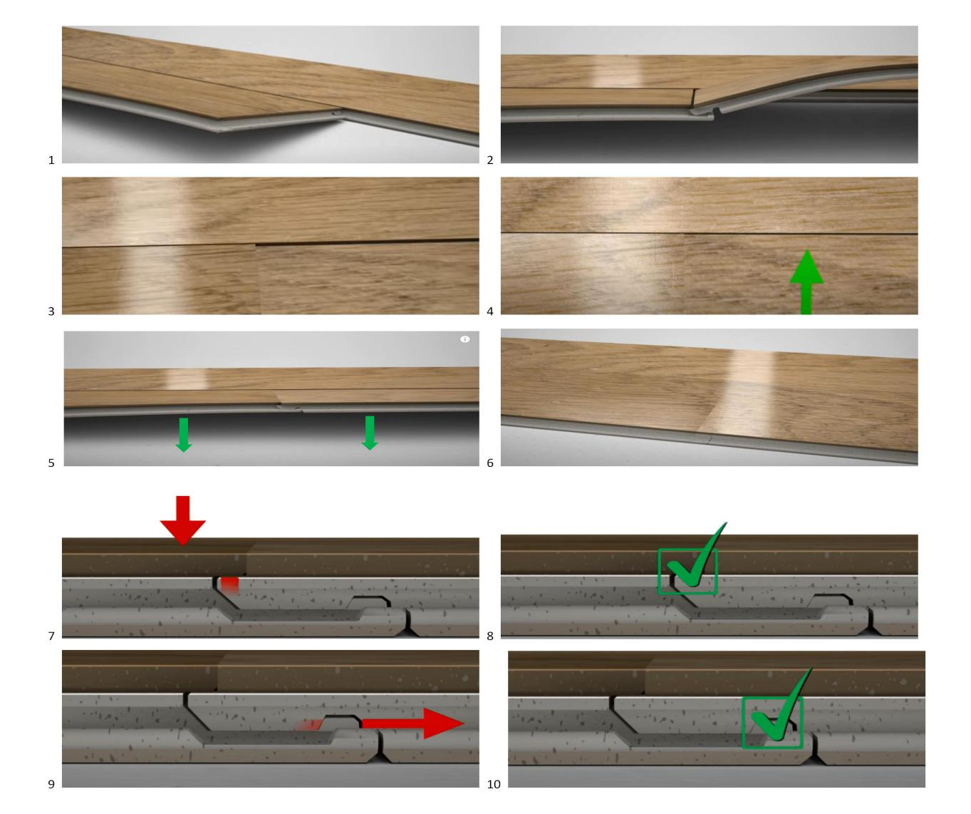

Installation over radiant heated subfloors

MBA Grande can also be installed on a radiant heated subfloor. However, installers and homeowners must adhere to the following directions:
- Radiant heating systems must be set to 15 °C (59 °F) 24 hours prior to MBA flooring installation.
- Following installation, the radiant heating system can slowly be increased in 5 °C increments, never exceeding 28 °C (82 °F).
- The owner and installer acknowledge that dramatic and sudden increases in temperature should never occur. It is recommended that a dedicated thermostat be installed to allow the temperature of the radiant heating system to be accurately controlled and maintained below 28°C.

Failure to follow these instructions may cause damage to the floor and will void the warranty.

Installation in direct sunlight of heavy load areas:

- For application in direct sunlight or exposure to excessive heat or in areas with heavy rolling traffic i.e. Dentists chairs, wheelchairs or dollies it is recommended to use Dry Back glue down Vinyl products but not our MBA Grande Click system.

After Installation:

- In bathrooms or other areas where moisture could reach the subfloor by migrating to the perimeter of the installation: caulk around the perimeter of the installation with silicone (or equivalent) caulking. Be careful not to caulk above the flooring height as it may impede the installation of wall base.
- Install specified transition strips where applicable.
- Never slide appliances or other heavy items across the floor. Use plywood and a hand dolly or an approved air-ride moving device.
- To control grit, use walk-off mats with backings that will not stain the floor.
- Use furniture glides and protectors to prevent scratching and indentations.
- Read and understand all maintenance and warranty information.

WARRANTY

10 Year Light Commercial Warranty/Lifetime Residential Warranty:

- Our limited light commercial warranty for MBA Grande means that for ten years (light commercial) or lifetime (residential), from the date of purchase, your floor will be free from manufacturing defects and will not wear through when installed and maintained according to these instructions. This guarantee applies only to the original end user and proof of purchase is required for all claims. The guarantee is for replacement or refund of the material only, no labor. Claims for wear must show a minimum dime size area.
- High-heeled shoes, rolling carts, furniture and chairs without protective pads can damage the floor and are not covered by this warranty.
- Gloss reduction is not considered surface wear-through. Gloss changes are not considered surface wear. Excessive wear along the edges and bevels of individual boards (within 1/8” or 3mm of the edge of the panel) is not covered by this warranty. Scratches, indentations, marks, stains, or other damage caused by negligent or accidental exposure to pebbles, grit, sand or other abrasives, pets, insects, high heeled or cleated shoes, fire, product spills, excessive moisture, heat or dryness are not considered normal wear and tear and are not covered by the warranty.
- The installation and warranty guide can be viewed and downloaded from our website.

MAINTENANCE INSTRUCTIONS

INITIAL CLEANING
- Remove all traces of adhesive or dirt on the floor by dry vacuuming. Then, use a damp mop or recommended Vinyl cleaners to wash floor.

PREVENTIVE MEASURES
- The easiest way to reduce maintenance costs is to reduce the amount of dirt, grit and moisture brought into a building with an effective barrier mat. Mats should be cleaned regularly. The use of either rubber-backed mats or coco-fiber mats is not recommended as they are known to cause yellow stains in vinyl floors.
- Never slide heavy furniture or appliances over an unprotected floor. Severe scratching may result. Move heavy furniture or appliances over the flooring using casters or dollies. The manufacturer recommends that felt pads are used on any furniture that is placed on the floor. If other on-site trade work continues after installation of flooring, consider using a protective covering such as MBA Anti-Skid Hard Surface Protection to guard against damage to the new floor.
- Clean the floorcovering regularly, as this is more cost-effective and hygienic than occasional heavy-duty cleaning.

SPOT PROTECTION AND REMOVAL:
- Wipe immediately with a paper towel or cloth.
- The area should be washed with diluted cleaning agent, using a damp cloth or sponge.
- Difficult spots might be removed with a firm nylon sponge.
- Should the spot remain, moisten a cloth with clear odorless mineral spirits and rub with circular movements over the whole area. However, always test in an inconspicuous area to check for compatibility of the mineral spirits and flooring.

The following substances can cause discoloration:
• Tar • Lipstick • Coco-Fiber Mats
• Nail Polish • Solvent-based paints • Asphalt
• Shoe Polish • Rubber Mats • Permanent Markers

NOTE: Most domestic cleaning agents will not harm the floor, however all residue of cleaning agents should be removed to avoid discoloration. We recommend the top temperature should not exceed 85°F (29°C). As such, steam cleaners are not recommended. Damage due to the use of steam cleaners will void the warranty.

BASIC TIPS ON CARE:
- Regular light maintenance is more cost effective and beneficial than periodic heavy maintenance.
- Do not use soap-based detergents, caustic cleaners, or abrasive cleaners.
- Sweep, mop or dry vacuum the floor regularly.
- Always use clean equipment – dirty equipment only redistributes the dirt.
- Furniture polish and window cleaning sprays should be directly applied to a cloth to avoid spillage onto the floor.
- Always remove any spills immediately.
- Always remove excess water.
- Always take precautions to prevent dark rubber from contacting the floor.
- Always use the manufacturer’s recommended dilution rates.
- Wet floors are slippery; always use warning signs to advise that cleaning is in progress.

