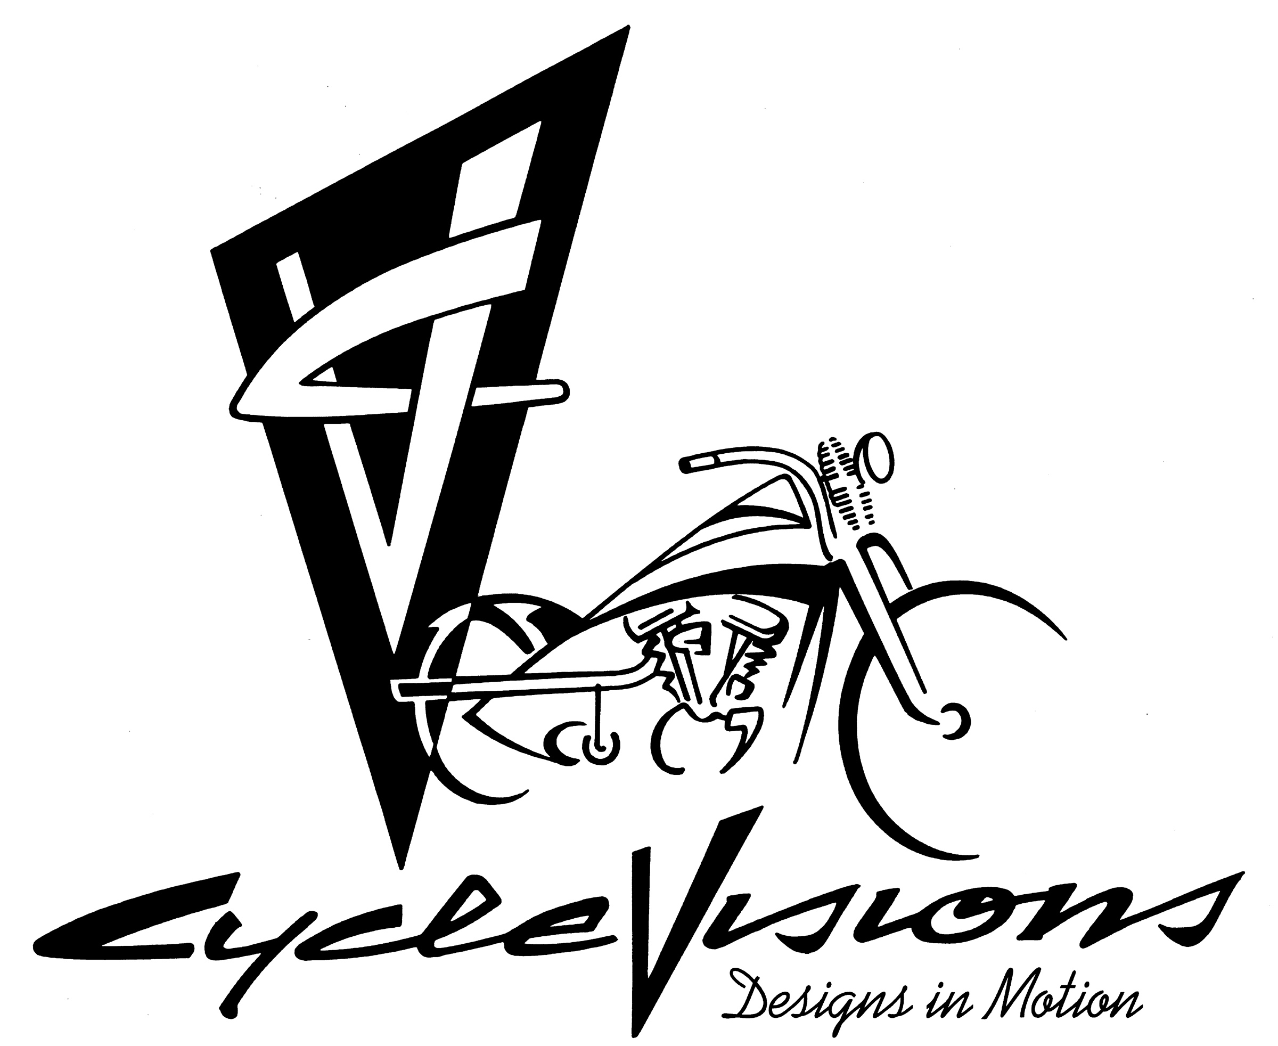 **CV-5020**

**Victory Handlebar Adapter**

Fits most 08-up cruiser & bagger models

Parts Included:

1ea- Handle Bar Adapter Plate 2ea-1/2-13 x 1 ½” Flat Head Alloy bolt

2ea-Spacers 2ea-1/2-13 Nyloc

2ea-1/2-13 x 4” Flat Head Alloy bolt 2ea-1/2 USS Flat Washer

1. **Must be installed by a Qualified Technician**
2. Drop the 4” bolts through the outside holes of handlebar adapter.
3. Insert the 1 ½ bolts from the bottom up into the handlebar risers

**NOTE: The riser footprint MUST be 1 1/8” Diameter or LESS with a ½-13 thread**

1. Place the long bolts thru the spacers and into the triple tree.
2. Secure with the flat washer and nylocs.
3. Torque to factory specs
4. **Use red loctite**

**Our Warranty Policy**

Cycle Visions’ obligation under “Our Warranty Policy” is limited to one (1) year from date of purchase to repair or replacement of the defective item (s). Chrome, polished, powder-coated, anodized finishes, or electrical parts are limited to thirty (30) day from date of purchase.

This warranty will be void on all products that show evidence of misapplication, improper installation, abuse, lack of proper maintenance, negligence, or alteration from their original design.

The consumer will be responsible for removing from the vehicle any defective item (s), transportation costs prepaid and for reinstallation upon return by Cycle Visions. The loss of use of the product, loss of time, inconvenience, commercial loss or consequential damages is not covered. Cycle Visions reserves the right to change the design of any product without assuming any obligation to modify any product previously manufactured. Warranty returns of Cycle Visions products are few because of our high quality products.

Carefully inspect all parts…. If you find that your parts arrived in damaged conditional all original packaging material (box and other materials) must be saved to make a proper damage claim within seven (7) days. You must be able to present the damaged boxes and materials to the freight carrier to verify your claim. The user shall assume all legal, personal, injury risk and liability and all other obligations, duties and risks associated therewith.

***Cycle Visions***SM

San Diego, CA

(619) 295-7800

See our other products on the web!

