

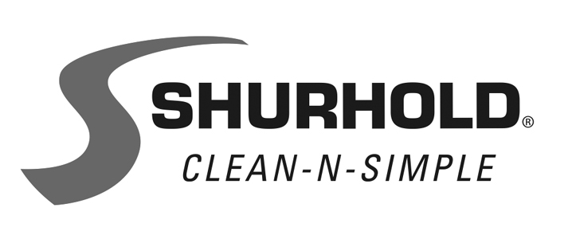
3119 S.W. 42nd Avenue, Palm City, FL 34990-5558
www.shurhold.com

X-19444

THE SCIENCE BEHIND MICROFIBER TOWELS

The debate of using regular cotton towels versus microfiber towels on painted surfaces, fiberglass, vinyl and plexiglass has been long-standing. Shurhold Industries is a solid supporter of the microfiber choice.
The softness of microfiber towels comes from their composition of polyester and polyamine, which are thinner than human hair. They absorb 98% of water, whereas cotton can only absorb 70% at most. Microfiber also picks up dirt, oil and other contaminants and locks them away in the tiny hooks of the fabric until it's washed or rinsed. Regular cotton just pushes the dirt along the surface, increasing the chances of scratches and imperfections.
Microfiber towels are elastic, resisting tension and returning to their original state. They are safe to use with most chemicals and are easy to wash either by hand or in the washing machine, as long as fabric softener isn't used. They're great for washing, waxing and polishing a boat, car, RV or house.
Dedicated to educating boat owners, Shurhold offers a free guide of 5 key tips for boat value preservation at www.shurhold.com/tips. Inventor of the One Handle Does It All system, Shurhold manufactures specialty care items and accessories to clean, polish and detail.
Contact Shurhold, 3119 SW 42nd Ave., Palm City, FL 34990 USA. +1-772-287-1313; Fax: +1-772-286-9620. www.shurhold.com.

-more-

