

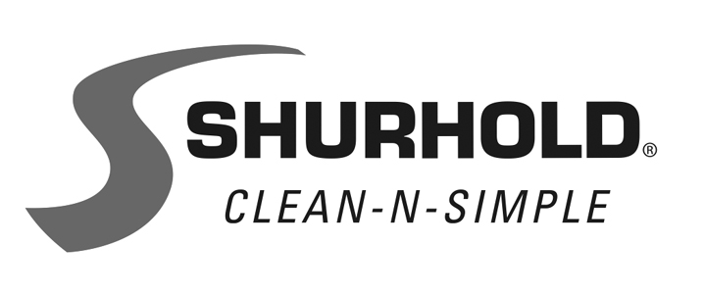
3119 S.W. 42nd Avenue, Palm City, FL 34990-5558
www.shurhold.com

25783

BUCKET IS BOAT DETAILING STATION IN DISGUISE

Few boat accessories are as useful as the One Bucket System from Shurhold. As a detailing station, it's unrivaled for its ingenuity and transforms the washing experience. And whether stored in a dock box, garage or below decks, it holds a wide range of soaps, sprays and tools all in one convenient place.
Made in the USA, the basic One Bucket System starts with Shurhold's black or white five-gallon World's Best Rope Handle Bucket. Instead of a rust-prone wire hoop that's difficult to grasp and can scratch fine finishes, it features a soft 3/4" braided rope. Constructed from heavy-duty plastic that's thicker than a standard pail, the bucket is strong enough to stand on using the combination Bucket Lid/Padded Seat. A video is at www.bit.ly/ShurholdOneBucket.
Inside the World's Best Rope Handle Bucket are a series of removable inserts. The Bucket Grate sits on the bottom where dirt drops out of the soapy water through integrated baffling as a brush or wash mitt is scrubbed against it. Two integrated 3 oz. measuring cups make it simple to achieve the recommended cleaning product ratio and twin finger holes make it a snap to remove.
On top of the grate is the Bucket Caddy. Two compartments store bottles, spray jars and small tools. The perforated bottom ensures water drains while a handle makes it easy to move around while working.
-more-
-2-
Shurhold offers a step up with its Deluxe One Bucket System, which adds the Bucket Base. This sturdy non-skid, non-marking ring minimizes sliding and tipping when long brushes are dipped into the bucket and scrubbed against the grate.
For those wanting a complete boat detailing solution, Shurhold's Ultimate One Bucket System answers the call. It includes the World's Best Rope Handle Bucket with Bucket Lid/Padded Seat, Bottom Grate, Bucket Caddy and Bucket Base, then adds a 32 oz. bottle of Shurhold Brite Wash, 16 oz. container of Pro Polish Wax, 32 oz. SMC Cleaner, 16 oz. spray bottle of Serious Shine and a 22 oz. can of Buff Magic Compound.
The Shurhold One Bucket System costs $54.98; the Deluxe version, $74.98; and the Ultimate model, $159.98. Individual items are also available separately.
Dedicated to educating boat owners, Shurhold provides key tips for boat value preservation at www.shurhold.com. Inventor of the One Handle Does It All system, Shurhold manufactures specialty care items and accessories to clean, polish and detail.
Contact Shurhold, 3119 SW 42nd Ave., Palm City, FL 34990.
800-962-6241; Fax: 772-286-9620. www.shurhold.com.

