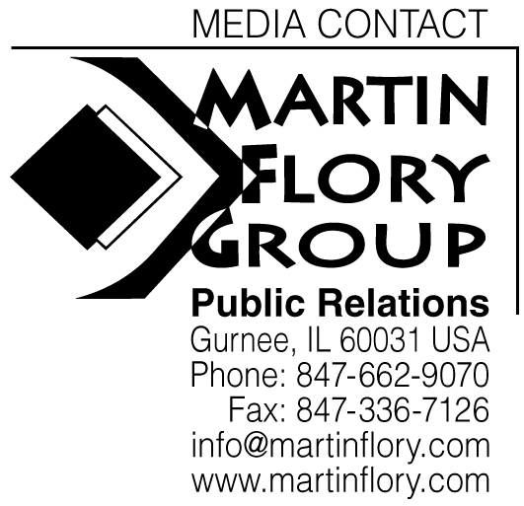

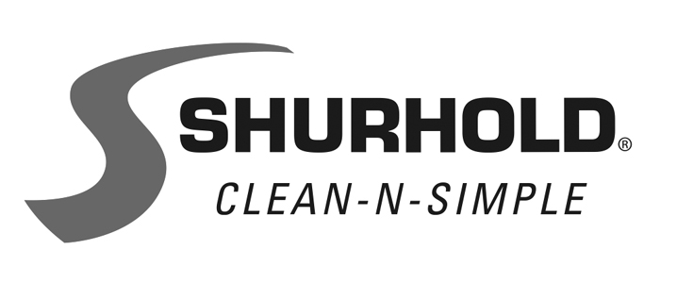
3119 S.W. 42nd Avenue, Palm City, FL 34990-5558
www.shurhold.com

25058

KITS SIMPLIFY BOAT CLEANING TOOL SELECTION

Whether just off the showroom floor or aging gracefully, every boat needs to be cleaned to keep it looking its best. Using its One-Handle-Does-It-All system as the foundation, Shurhold gathered the vital maintenance gear needed by owners into two Clean-N-Simple kits.
Both the Basic Boater and New Boater Kits start with a sturdy 6' Shurhold Telescoping Handle. Made in the USA, the heat-treated aluminum handle is triple anodized and locks at four lengths between 40" and 72". It features the SHUR-LOK quick release system to quickly snap on and off the two crucial tools included in the kits: the 3-in-1 Boat Hook and a premium quality Soft Deck Brush. Now, new boat owners only need to own and store one handle. Over 40 different Shurhold attachments are available that use this system.
The New Boater Kit adds a Dock-A-Reni that attaches to the handle and makes line handling a breeze—even for experienced boat owners. It also includes a 32 oz. bottle of concentrated Brite Wash. This quality multipurpose boat soap cleans without stripping wax or leaving water spots behind.
Along with the Brite Wash, the more advanced Basic Boater Kit adds a Flexible Water Blade. Used in the hand or attached to the Shurhold handle with the included adapter, it sheets water away from surfaces
-more-
-2-
before spots can form. For the final touch, the kit includes a 14 oz. can of Serious Shine, the one-step detailing spray, and a 3-pack of Microfiber Towels.
Shurhold's New Boater Kit costs $98.98. The Basic Boater Kit costs $166.86.
Dedicated to educating boat owners, Shurhold provides key tips for boat value preservation at www.shurhold.com. Inventor of the One Handle Does It All system, Shurhold manufactures specialty care items and accessories to clean, polish and detail.
Contact Shurhold, 3119 SW 42nd Ave., Palm City, FL 34990.
800-962-6241; Fax: 772-286-9620. www.shurhold.com.

