The AKU-MICRO scale Bluetooth version support firmware update .

How to update AKU -MICRO scale firmware? – IOS device
1, Download and save the new firmware of AKU scale inside your phone.
https://www.variabrewing.com/pages/aku-bluetooth

2, Download App: nRF Connect
3, Turn on AKU scale and Turn on phone’s Bluetooth
4, Enter into tool App: nRF Connect
5, Choose Device name: AKU SCALE or Varia-AKU- Mirco , click “ Connect “
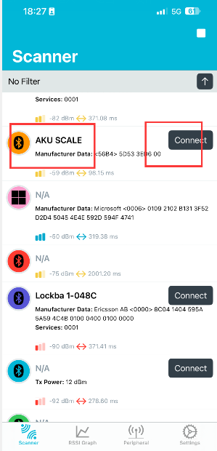

6, Click “ Client “ Find the “ FFF2 “ which under “ FFF0 “ , Choose “ upload arrow “
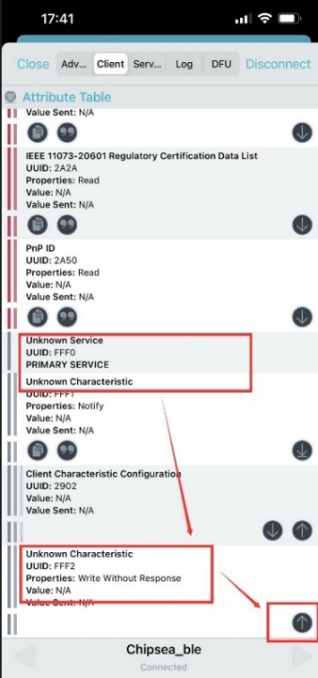
7, Select “ UTF8” ( IOS)
8, input “ WSD_OTA”
9, click “ Write” ( IOS )

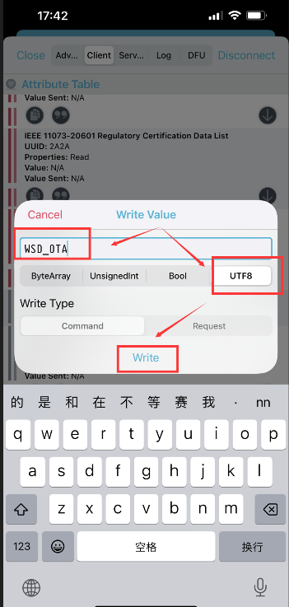
10, Click “ Connect” and then click “ DFU”, last “ Open Document Picker”
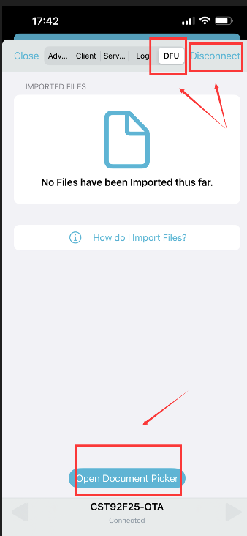

11, Select the new scale firmware which you downloaded and installed into your iphone earlier. Click “Start”

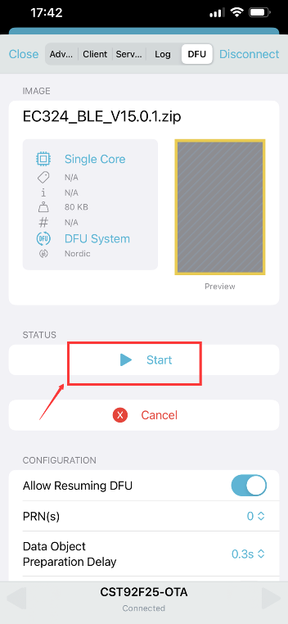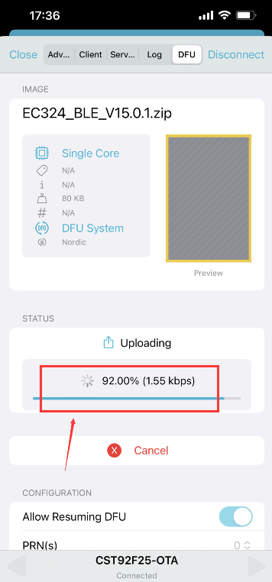
12, After 100% down, App showed Success and Scale auto turned on.
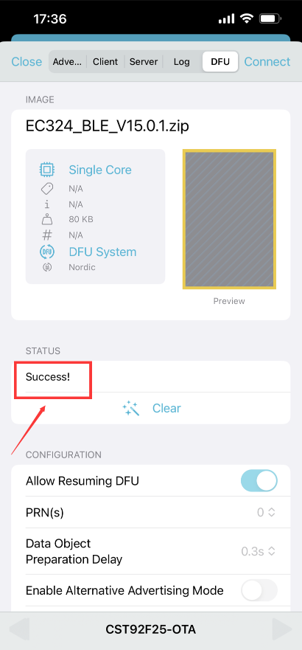

13，Turn off the main switch which next to charge socket for 30 s. Then turn on again.
This 30 s is purpose for make scale with lastest firmware fully saved and reflashed.
After step 13 Now you are able to enjoy with newest scale firmware.

The AKU MICRO scale Bluetooth version support firmware update .

How to update AKU MICRO scale firmware? – Android devices
1, Download and save the new firmware of AKU scale inside your phone.
https://www.variabrewing.com/pages/aku-bluetooth
2, Download App: nRF Connect
3, Turn on AKU scale and Turn on phone’s Bluetooth
4, Enter into tool App: nRF Connect
5, Choose Device name: AKU SCALE or Varia-AKU- Mirco , click “ Connect “
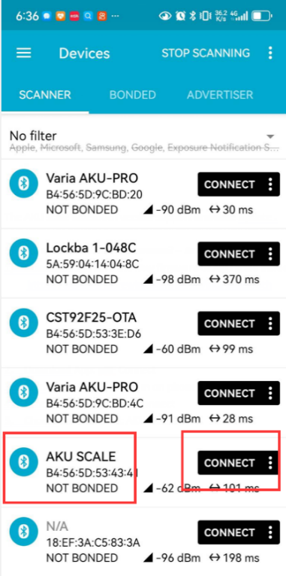

6, Click “ Client “ Find the “ 0xFFFO “ and enter into
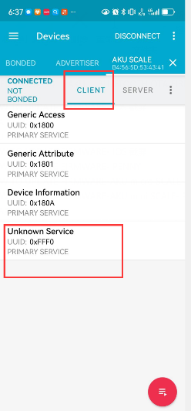
7, Find “ 0x FFF2 “ Click the right “ up arrow”
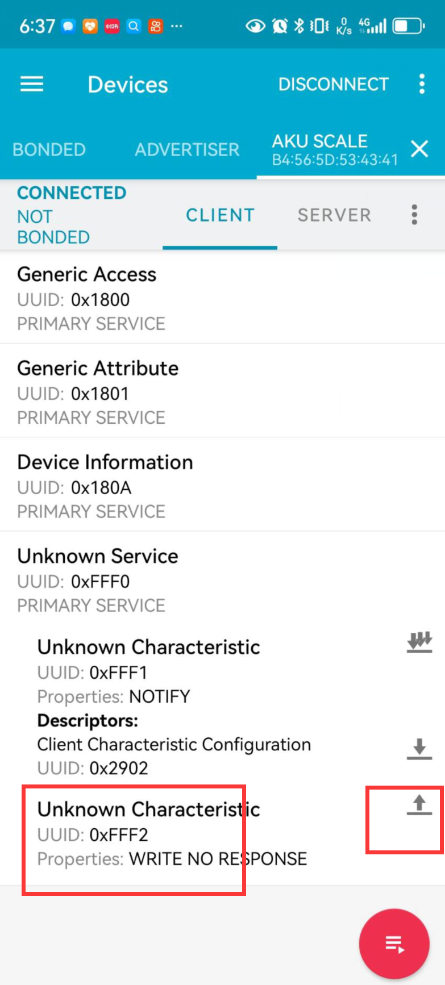
8, Click “ down triangle” next to “ BYTE” , select “ TEXT ( UTF-8) “
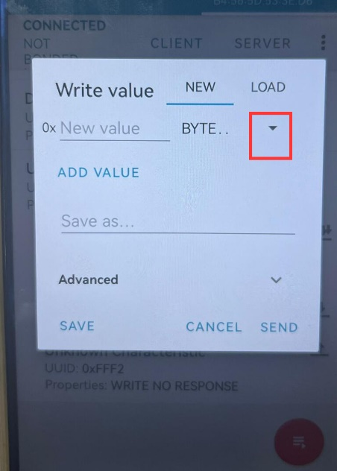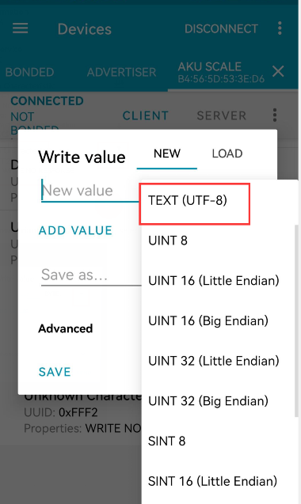
9, input “ WSD_OTA” and click “ SEND”
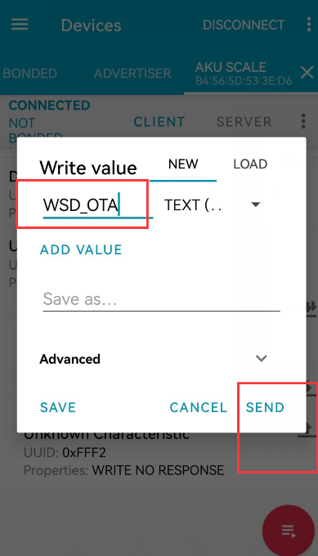

10, Click “ CONNECT” enter into pages then click “ DFU “
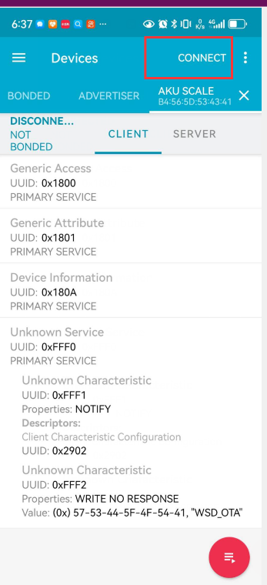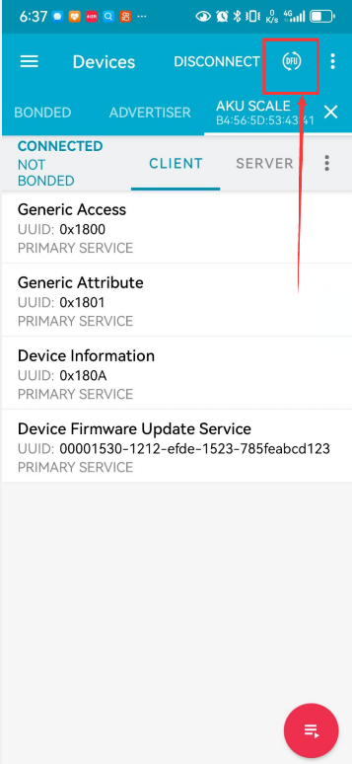

11, Select file type and click “ OK” enter into the files.
Select the latest firmware you download and save inside phone. Example V15.27
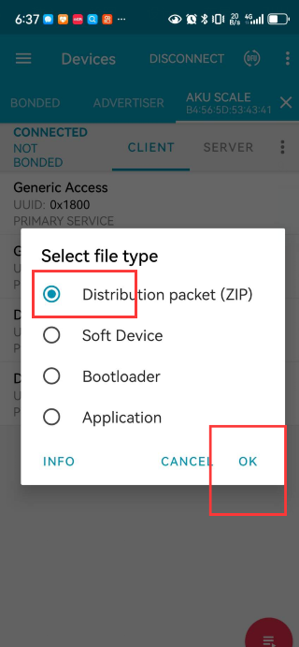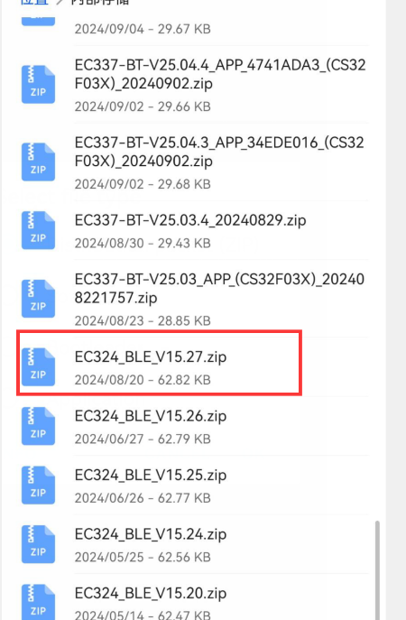

12, After Firmware selected , will auto enter into update page. And once finished and successed show the final pages.
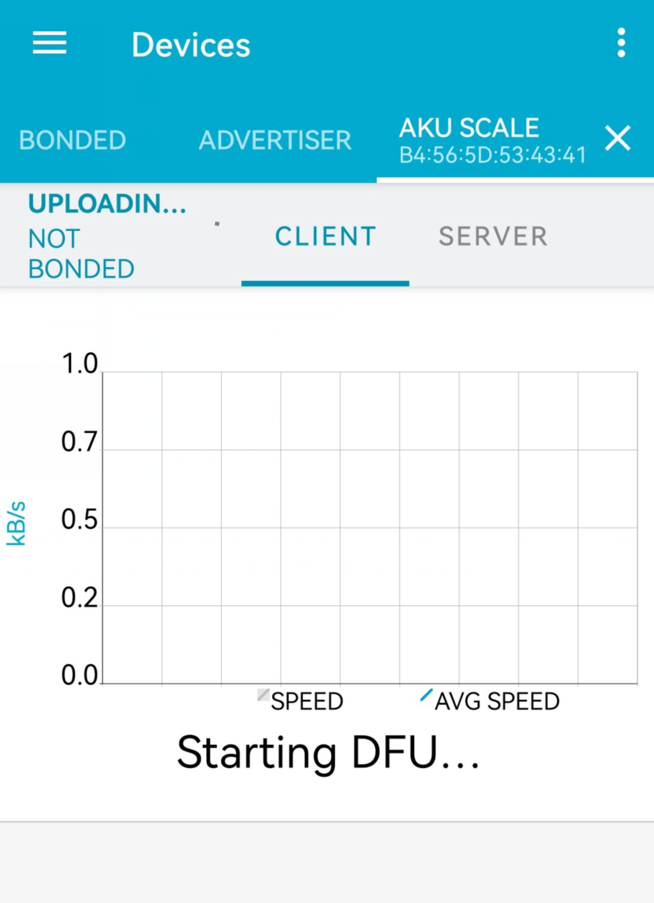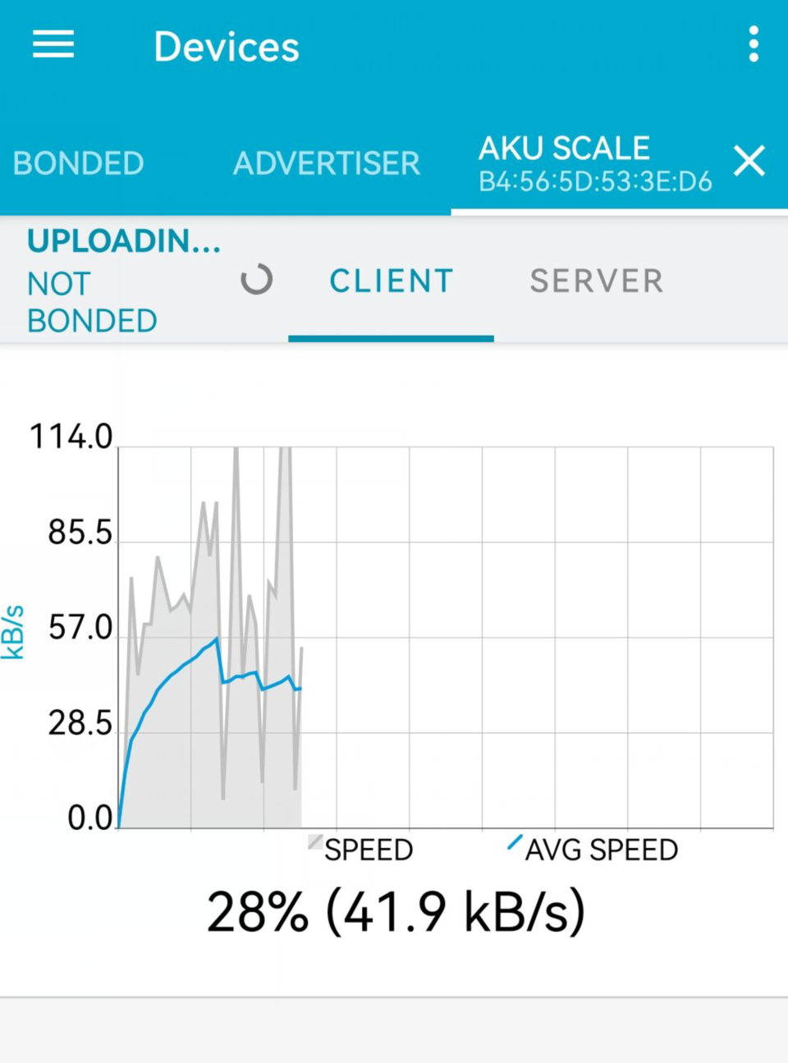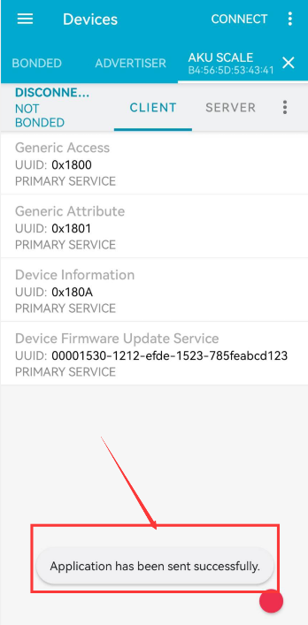
13，Turn off the main switch which next to charge socket for 30 s. Then turn on again.
This 30 s is purpose for make scale with lastest firmware fully saved and reflashed.
After step 13 Now you are able to enjoy with newest scale firmware.

