Car Tent Bubble Assembly Instructions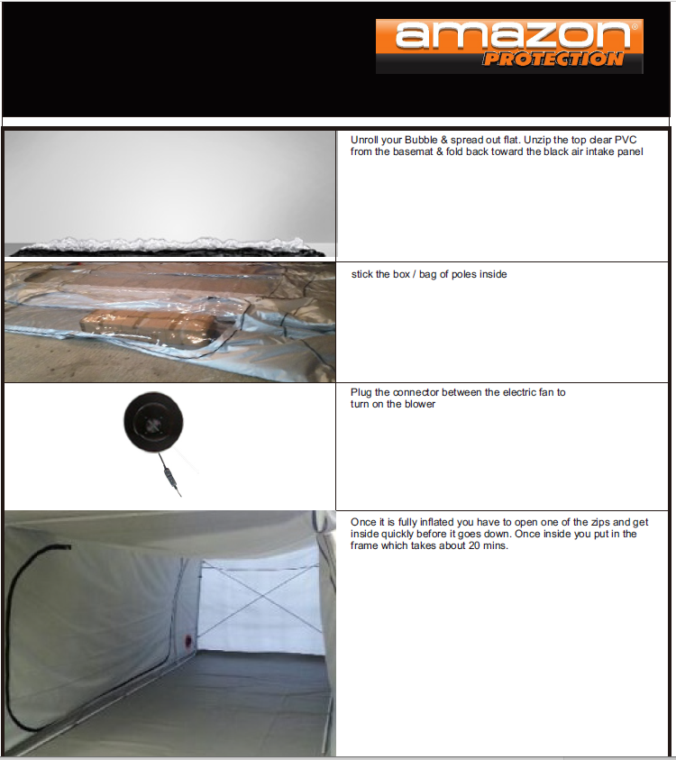s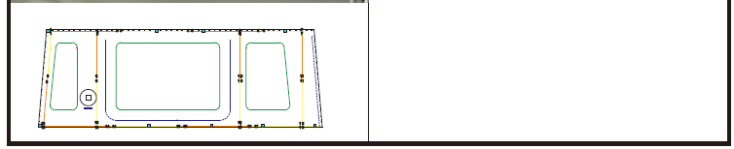
Have a good look at the last photo above. The frame can be clearly seen. (No frame obviously at the back/entry). The DC fan can be seem on the left side and the cross attachment frame on the front side (maybe back wall to some).
Tip, to begin with, treat your new tent the same way as a Car Bubble. A good video for installation is at the foot of the Premium Motorcycle Bubble page at www.carcoversandshelter.com.au
General (blow up) View from Bottom of page 1
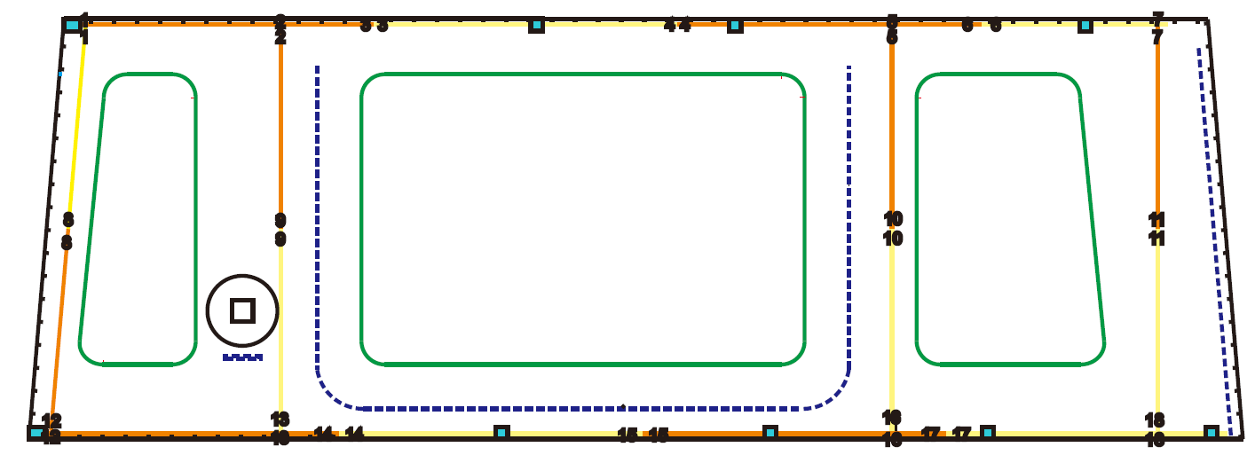
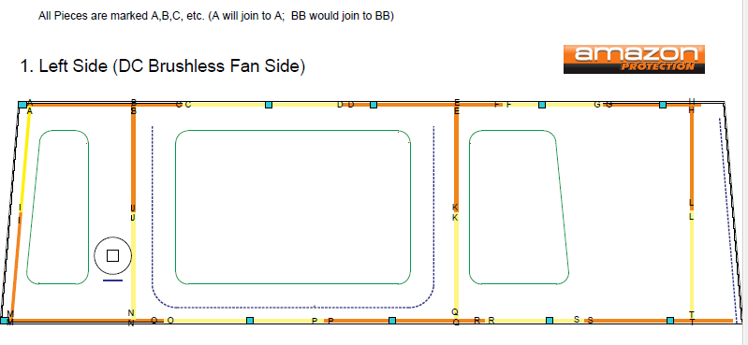

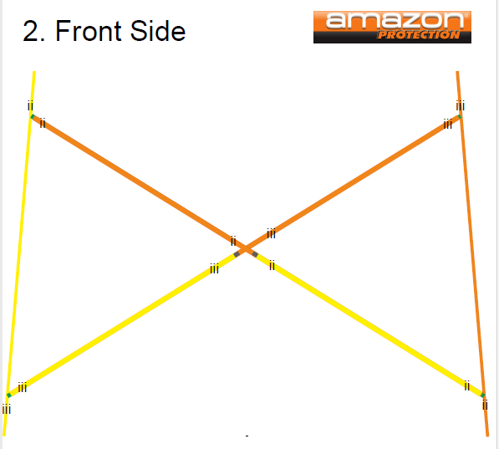

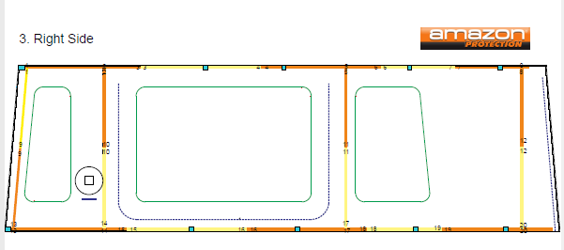

Now it’s fully assembled, Slip back out the door and your Tent Bubble is complete – just unzip and drive in and out anytime you want!

