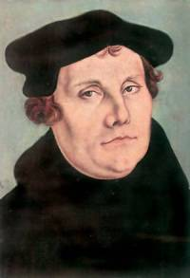

KEY POINTS
- Luther believed that people could be forgiven for sinning by being faithful to God. He called this Justification by faith alone.
- Luther objected to John Tetzel who claimed that people could be forgiven by buying an indulgence.
- Luther wrote down 95 of his objections and nailed them to the door of Wittenberg church.
- These objections became known as the 95 theses.
- Luther gained popular support for his ideas as a result of the printing press.
- The Pope ordered Luther to appear at a public debate to discuss his objections.
- The Pope issued Luther with a letter known as a Papal Bull which excommunicated him from the Catholic Church.
- Luther responded by burning the Bull.
- The Holy Roman Emperor, Charles V, invited Luther to discuss his views at a meeting in Worms in 1521. This event became known as the Diet of Worms.
- At this meeting Luther defended his views. He was supported by Frederick the Great, ruler of Saxony.

QUESTIONS:

- Explain what Luther meant by “Justification by Faith”

- Why was Luther so opposed to the work of John Tetzel?

- Look at the picture of Luther nailing his objections to the church on page 146. How do you think he would have felt as he did this?

- How did the Pope respond to Luther’s criticism of the Church?

- Write a paragraph describing what happened at the Diet of Worms in 1521.

