Christopher Columbus (1451 – 1506)
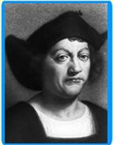
Columbus’s early life:
- Columbus was born in the Italian port of Genoa in 1451.
- He worked on a ship’s crew from a very early age and gained plenty of experience at sea. In 1476 he was shipwrecked off the coast of Portugal, he swam ashore and decided to live his life there.
- Columbus continued to work on ships and made many voyages to Atlantic countries in the west of Europe.
- Columbus read a lot about the wealth of India and China and tried to think of a new way to reach these wealthy countries in order to trade with them.
- Columbus also studied old maps. He discovered an old Greek map that convinced him that he could sail westwards to India and the Spice Islands rather than travel east across land and sea in order to trade.
- At this time this area was called the East Indies so he decided to call his expedition The Enterprise of the Indies.
Getting ready for his voyage west:
- Columbus needed funding in order to carry out his voyage.
- He went to the King of Portugal but the King was more interested in finding a trading route by sailing around Africa rather than sailing west and he didn’t give Columbus what he was looking for.
- Columbus then moved to Spain and put his idea to King Ferdinand and Queen Isabelle.
- Columbus convinced the King and Queen that he could find them a new trade route to India, beating Portugal in the race to gain wealth from the east. The King and Queen also saw the voyage to new lands as an opportunity to spread Christianity.
What would Columbus gain by completing this voyage?
- As well as being a pioneer in his field of exploration Columbus would receive:
- 10% of the wealth he discovered
- And become Governor of any new lands he discovered.
The voyage west:
- 3rd August 1492, Columbus set sail from the port of Palos in Spain.
- There were three ships on the voyage, the Nina, the Pinta and the Santa Maria. Columbus travelled on the Santa Maria.
- The Santa Maria was the largest ship up to 100 feet long. The Nina and Pinta were smaller ships at only 70 feet long, both of these ships were caravels.
- There were a total of 90 sailors on board the three ships.
- They first sailed to the Canary Islands to get supplies and ready the ship for the journey. They brought food such as salted meats, ship’s biscuit, dried fish, garlic, beans, rice and wine.
- Columbus believed it would only take them 2 weeks to reach the East by sailing westwards..
- 6th September 1492, they left the Canary Islands and set out on their journey.
- At that time ships rarely left the sight of land, Columbus was a pioneer in exploration, taking the great risk of sailing out into the open sea.
- After thirty days on the ship (well over two weeks!) the sailors were terrified, they began to think they’d never see Spain again.
- The sailors almost declared mutiny on Colmbus and force him to turn back around, 10th October 1492.
- Columbus showed the sailors a false log that told the sailors they had travelled only a short distance, this convinced the sailors to travel westwards a bit longer. Secretly Columbus kept a real long of their journey west, telling of a much greater distance the fleet of ships had sailed.

Land sighted 12th October 1492: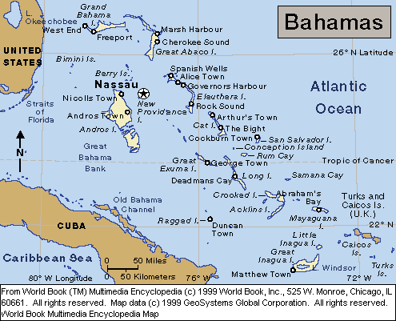
- 12th October the lookout from the Pinta fired a cannon shot as a signal that land was spotted.
- Columbus went ashore and claimed the land for Spain, calling the island San Salvador, which means Holy Saviour, obviously Columbus and his crew were happy to finally reach land.
- Columbus was convinced he had reached India and called the natives Indians.
- Columbus continued to look for the Indian mainland and a passage to the East.
- He hoped to find rich cities and the great wealth that he read of as a child.
- Columbus also found Cuba and Hispaniola (present day Haiti and the Dominican Republic).
Returning to Spain

- On Christmas day the Santa Maria hit rocks off the coast of Hispaniola and had to be abandoned.
- Columbus had to return to Europe on the Nina.
- He reached Portugal in March 1493 and soon afterwards returned to Spain.
- Columbus was greeted with a hero’s welcome in Spain. He brought back items that had never been seen in Europe before. For example, kidnapped Indianans, a little gold, parrots, turkeys, pineapples, tobacco and a hammock for sleeping in! These treasures delighted King Ferdinand and Queen Isabella and they gladly set Columbus up for a second voyage.

Columbus’s later voyages:
- In all Columbus sailed on three more voyages across the Atlantic. He explored Central and South America but never North America.
- He discovered Puerto Rico, Trinidad, Jamaica, Panama and the mouth of the Orinoco River.
2nd voyage (20th May, 1494 – 1496)
- His fleet was made up of 17 ships and over 1,000 settlers.
- On returning to Hispaniola Columbus found all the men, which were there from the previous voyage, dead and their fort destroyed. Columbus tried to rebuild the fort but many of the men died from foreign disease such as malaria.
- He found a small amount of gold on the island of Hispaniola. Columbus forced the natives to bring him gold and threatened to cut off the hands of natives that did not bring him gold, however there was no more gold to be found on Hispaniola.
- As a result Columbus sent 500 native Indians back to Spain as slaves in order to pay the cost of this expedition.
3rd voyage (30th May, 1498 – 1500):
- Columbus landed on mainland South American in an area that is now known as Venezula.
- This voyage ended in disaster for Columbus as he quarrelled with the new Governor of Hispaniola.
- As a result of the argument, Columbus was sent back to Spain in chains.
4th voyage (9th May, 1502 – 1504)
- Columbus investigated the Central American coast on this voyage.
- Columbus warned another Governor of Hispaniola of an approaching Hurricane. The Governor did not listen to Columbus and 24 ships were lost in the storm.
Did Columbus succeed?:
- Columbus arrived back to Spain in 1504 a very disappointed man:
- He had not discovered a new trade passage way to the East.
- He did not bring back spices or silks and only a little gold to Spain.
- Columbus still believed he found a new route to Asia, but that he hadn’t managed to reach the mainland.
- Though he didn’t realise if, Columbus had in fact discovered the “New World”.
Columbus’s final years:
- Columbus failed to find a new route to the East Indies and he became very unpopular in Spain, he had his title as Governor of Hispaniola stripped.
- Columbus became ill and died in Valladolid, 20th May, 1506.

What did he achieve?
Although Columbus died a disappointed man because he didn’t reach the East Indies he did have many achievements:
- Columbus’s discoveries caused great excitement within Europe and prompted many more voyages across the Atlantic.
- He was a pioneering explorer and the first man to sail out into the open ocean.
- He was the first European to explore and document the New World. (There is also some evidence to suggest that Vikings reached America around 1000AD and a legend that the Irish St. Brendan sailed across the Atlantic also.) This makes Columbus very important because the detailed record of his exploration was the first to be written about America.
- He inspired the writing of many books about America. Amerigo Vespucci lead voyages to the New World and he wrote about many of the places Columbus visited. His writings became widely distributed and people began to hear of the New World through Vespucci’s accounts. Hence, people began calling the new continent America.

