Maxrace F.1 converter.3.0 Manual
MaxRace-F-1 Converter 3.0
Usage manual

Before using the product, carefully read this manual and retain it for future reference.

Product feature & function:

- Supports the G25,G27 Clutch function.
- Compatible with 2 types of gear shift, manual gear shift and automatic transmission gear shift
- All G27, G25,MOMO,and GT racing wheel works on Xbox 360™ racing games.
- Compatible with all versions of Xbox 360™/Xbox 360™ slim, PS 3™/PS3™ slim consoles
- Support Force Feedback function
- More sensitive and accurate
- Plug and play.
- Enables Rapid Fire/Turbo on Wired Xbox 360™ and PS 3™ controllers when connected to your Xbox 360™/Xbox 360™ slim, PS 3 ™/ PS 3™ slim console.
- Support PS 3™ sixaxis games.
- Supports 2 stick analog tilt functionality from the PS 3™ controller to the Xbox 360™ .
- Support wired Xbox 360™ controller and PS 3™ controller on Xbox 360™/Xbox 360™ slim, PS 3™/PS 3™ slim console.

Device introduction:
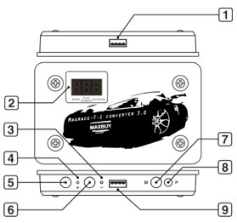

（1）USB Plug And Play
(Connects to PlayStation 3™ / Xbox 360™ console via USB port connection.)

（2）Digital screen
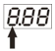

The first digit number is the Shifter (Shift gear): 0 means N (neutral gear), 1~7 gear and means R gear.
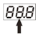

The second digit number is for force feedback setting: the force feedback function featuring 5 different levels, 1 is the weakest force feedback level, 5 is the strongest force feedback level. Once the force feedback level are set, the current setting will be automatically save on the MaxRace-F-1 Converter 3.0 and you can have the same setting for your next game play.
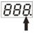

The last digit number is used for checking/setting the Sensitivity level: featuring 5 different steering sensitivity levels, 1 is the lowest sensitivity, 5 is the highest sensitivity. After the sensitivity level is set, the current setting will be automatically save on the MaxRace-F-1 Converter 3.0 and you can have the same setting for your next game play.
（3）“-”button indicator

（4）“+” button indicator

（5）When connected to Logitech™ G25/G27/GT/MOMO racing wheel, this “plus” button is used for push up on the shift level or enhance the force feedback level or increase the sensitivity of the racing wheel.
* This button doesn’t work on PlayStation 3™ / Xbox 360™ wired controller

（6）When connect to Logitech™ G25/G27/GT/MOMO racing wheel，this “minus” button used for push down the shift level or decrease the force feedback level or weaken the sensitivity of the racing wheel
* This button doesn’t work on PlayStation 3™ / Xbox 360™ wired controller

（7）Mode Button
This button is used for setting the digital number, the default setting for the shifter is (the first digit number), you are able to adjust the shifter setting by clicking on the “+” or “–” button.
If you press this button once, it is be moved to the 2nd digit number, you are able to adjust the force feedback level by pressing on the “+” or “-” button.
Press this button again, the digit number moves to 3rd number, and you are able to adjust the Sensitivity level by pressing on the “+” or “-” button.
If you press the M button again, it will return back to the 1st digit,(for setting the Shifter level), each press will switch to next digit and change the mode in circulation

（8）Program Button

（9）USB Port
(PlayStation 3™ / Xbox 360™ wired controller or Logitech™ G25/G27/GT/MOMO racing wheel plugs into this port.)

How to connect:

(1) Using on PS3™/PS3™ slim console:
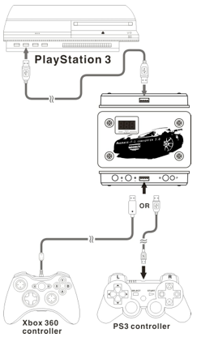

(2) Using on Xbox 360™/ Xbox 360™ Slim console:
Note: the Official WIRED 360 controller must be required when using MaxRace-F-1 Converter 3.0. *NO PLAY AND CHARGE USB CABLE.
The working step is as below:
First, connect the MaxRace-F-1 Converter 3.0 to the Xbox 360 console and then plug in the WIRED Xbox 360 controller. Wait until the Guide key stops blinking. Connection is successful.
Second, unplug the WIRED Xbox 360 controller and plug in the PS3 controller or the Logitech G25/G27/GT/MOMO to play your game.
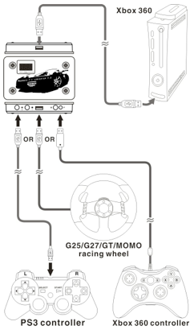

How to use the Rapid fire function:

Connect the Xbox 360TM or PS 3 TM wired controller to the MaxRace F-1 converter 3.0 , you are able to use the Rapid fire function on these 2 controllers.
If you want to set the rapid fire function on the A button of Xbox 360 TM wired controller, the setting step are shown below:

Press the P button <8> once, when the digit tube shows the T ,press the “A”button on the Xbox 360TM wired controller, the T light turns off, the setting is completed, the “A” button has the rapid fire function.
If you want to remove the rapid fire function on the “A” button, simply repeat the above steps.
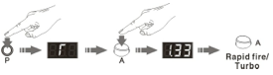

How to use the tilt functionality:

- On Playstation 3™ console:
Connected the Xbox 360TM wired controller to MaxRace-F-1 Converter 3.0, you are able to set the tilt function on the PS 3 TM wired controller to the analog stick of Xbox 360TM wired controller, the steps are shown below:

For instance, if you want to set the tilt function to the LEFT analog stick of Xbox 360TM wired controller:
Press the P button <8> once, the digit tube <2> shows the word“P”, now turn the xbox 360 controller left analog stick 360 degree around (no matter right or left turn) ,the digit tube <2> shows the word shows the word “F-1”, the tilt function is enable on the left analog stick of Xbox 360TM wired controller.
If you want to remove the above setting, simply repeat the steps again.

For setting the tilt function on the RIGHT analog stick of Xbox 360TM wired controller, the method is the same.
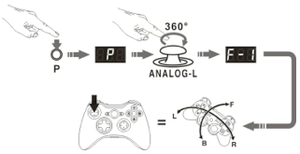

B. On Xbox 360™ console:
Connect the PS 3 TM wired controller to the MaxRace-F-1 Converter 3.0, the tilt function on the PS 3 TM wired controller can replace the Xbox 360TM wired controller analog function, the operating method is as below:
If you want to set the function of the LEFT analog stick of Xbox 360 TM wired controller to the tilt function on PS3 TM controller.
Press the P button <8> once, the digit tube <2> shows the word“P”, now turn the Xbox 360 TM wired controller left analog stick 360 degree around(no matter right or left turn) , the digit tube <2> shows the word shows the word “F-1”, the PS 3 controller tilt function is replaced by the function of left analog stick of Xbox 360TM wired controller, and the original function of the PS3 LEFT analog stick is temporarily malfunction.
For setting the RIGHT analog stick function of Xbox 360TM wired controller to the PS3 controller tilt function, the method is the same as mention above.
If you want to remove this function, simply repeat the steps above again.
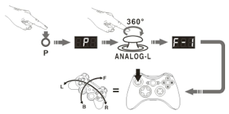

Default configuration:
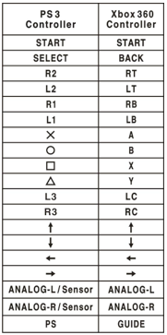

Ⅵ. Connect to Logitech™ G25/G27/GT/MOMO racing wheel:
(1) MaxRace-F-1 Converter 3.0 is compatible with the Logitech™ G25/G27/GT/MOMO racing wheel, the default setting for the keys are as below on a Xbox 360™ console:
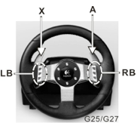

Wheel turns right = Left Analog Stick turns right.
Wheel turns left = Left Analog Stick turns left.
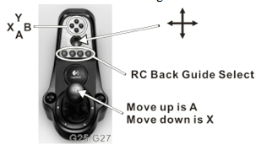
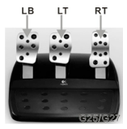
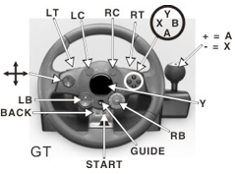
Wheel turns right = Left Analog Stick turns right.
Wheel turns left = Left Analog Stick turns left.
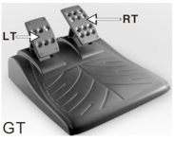
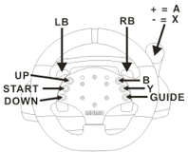
Wheel turns right = Left Analog Stick turns right.
Wheel turns left = Left Analog Stick turns left.
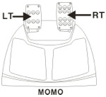
When connecting the MaxRace-F-1 Converter 3.0 to Logitech™ MOMO racing wheel, you must wait for the MOMO racing wheel to complete its self test (clockwise and anti-clockwise for 120⁰ degree then force feedback to let the wheel returns back to the middle) , press the gas pedal (RT pedal) to activate the MOMO racing wheel.

(2) Custom button settings on the Racing wheel.
The custom setting is based on different kinds of games to reset the buttons for your own need
A: Custom setting for the gear shifter
The default setting for the gear shifter are push up = A , push down = X, if you want to set the push up to Y , the steps are shown below:
First press the program button P <8>, the digit tube shows, now push the stick up then push down the shift lever in neutral. The digit tube shows and blinks, now press once on the Y button, the digit tube turn off, the setting is completed.
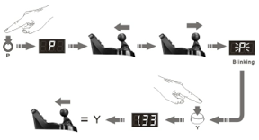

B：Swap the racing wheel buttons’ function:
Logitech™ G25/G27/GT/MOMO racing wheel buttons’ function (Except Guide key）can be swapped, the operating method is as below:
If you want to swap the button A function with the X button: Press the “P” switch, the digit tube shows, then press the X button, the digit tube shows and blinks,
Now press the A button, the digit tube turnoff, this means the setting procedure is complete, the X button now has the A button function.
Now if you want to set the X button function to the A button, just do the same steps, even though X button is already programmed to function as the A button.
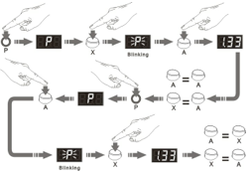

If you want to return back to the original A button function, please follow these steps: Press “P” button– the digit tube shows, –press A button– the digit tube showsand blinks,–press A button again– the digit tubeturn off, now the A button will have its original function.
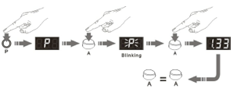

How to set all the buttons back to their own functions:
Press and hold the “P” switch for 3 seconds，the digit tube shows Cand blinks, release the P button, all the buttons will return to their own functions now.
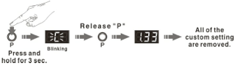
(3) In regarding to different racing games and different kinds of shifter gear setting, you have to adjust the shifter gear digit number on MaxRace-F-1 Converter 3.0 (shifter + or -) to match the right gear position on the game before playing or resume the game.

(4)Connect the MaxRace-F-1 Converter 3.0 to Logitech™ G25/G27 racing wheel, the default setting is manual control, you are able to use the gear shift (+ or -) to control the shifter gear.(Push upward is for the higher gear level, push downward is for the lower gear level), the steps are as below:
Press and hold the M button on the device for 3 seconds, wait the digit tube shows and blinks, now release the M button, the setting is completed , the mode is changed from manual control to + and – mode controls.
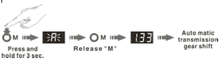

Press and hold the M button on the device for 3 seconds, wait the digit tube shows and blinks, now release the M button, the setting is completed , the gear shifter is changed from + and – mode control to manual control.
