PRESS RELEASE from Prova Records Wednesday, 14 March 2014

IMMEDIATE RELEASE:

MICHEL BISCEGLIA PRESENTS A MATURE YET PLAYFUL ALBUM

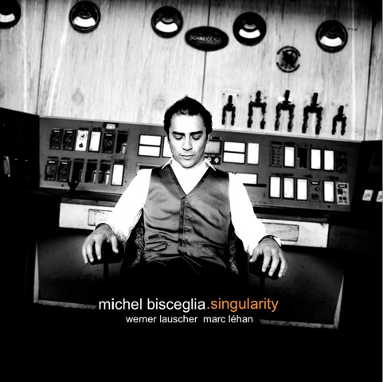
After having written 8 soundtracks in the last 3 years, Michel Bisceglia decided that the time was right to head back into the studio to record a new album with his jazz trio. The song ‘Passion Theme’ on Singularity is a reference to the latest soundtrack Michel Bisceglia composed for the film ‘Marina’ directed by Stijn Coninx.

Singularity refers to the relationship between humans and artificial intelligence, and the level of technological evolution which will eventually become incomprehensible for contemporary humans.

This concept has always fascinated Michel Bisceglia, since he experiences a similar correlation between humans and music - they strongly influence and stimulate one another, often beyond the boundaries of what is comprehensible to mankind.

The trio was formed almost 20 years ago, and they still perform in their original line-up. This results in a wonderful group dynamics and a musical maturity which is reflected most by the wavelike motions that Werner Lauscher (upright bass) and Marc Léhan (drums) produce in their accompaniment. Because of this they offer pianist Michel Bisceglia the freedom to give free course to his sophisticated and expressive improvisations.

The gained experience in the course of years in combination with the amazing atmosphere in the studio have resulted in the bonus-cd ‘My Ideal’, which has been added to the album. This bonus-cd contains re-recordings with new interpretations of earlier released songs.

Artist: www.michelbisceglia.org CD Distribution (Benelux): www.lcmusic.com
Contact booking: kati.vandevelde@redcatartists.com Music available online

