Instruction Sheet – Installation of the EDGIT - Stihl
=========================================================================
Warning! Trimmers produce flying debris!
Always wear eye protection while operating a trimmer!

Edgit Installation:

1) Remove bump head and the guard.

2) Install mounting block on gearbox flange with the four bolts, flat washers and lock washers. The mounting block face with ground away area in the crotch of the Y must face upward for clearance.

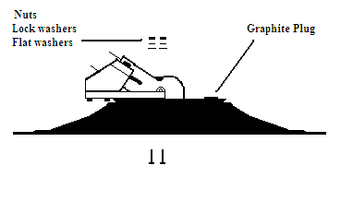
3) Put the two 1.25” screws up through EDGIT, then through the two holes in mounting block (Use holes that are marked). Make sure the gearbox is centered in EDGIT center hole. Do not cover the graphite plug with the mounting block.

4) Place a flat washer, lock washer and nut on the screws, on the top-side of the block. Tighten until screw heads seat into the sockets on bottom of EDGIT.

5) Replace bump feed head.

String Placement:
The EDGIT is designed so its outer lip is placed immediately adjacent to the plane of the spinning string using the standard factory bump head. However, it’s possible the trimmer manufacture or you may have installed a different head. Check for correct placement by looking across the plane formed by the opposite sides of the lip. The eyelet hole should be just visible beyond the aligned lips as shown in the illustration.
If the eyelet hole is inside the disk slightly, place a metal washer under string head to move string outward.
If the eyelet hole is more than an 1/8” beyond the lip your trimmer may cut a wider edge than desired. A spacer between the gearbox and the EDGIT may be required to place the EDGIT’s lip adjacent to the spinning string plane.
Good luck, if you have any questions call 859-384-3276.

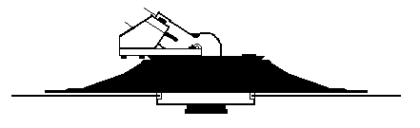
Using the EDGIT:
Several inches of string should extend beyond the EDGIT’s outer lip while operating the trimmer.
Operating most commercial straight shaft trimmers is best accomplished holding the trimmer LEFT HANDED. Refer to our FOLLOWING THE EDGIT manicuring and training system.
Experienced operators may resist using the EDGIT just because it's something new. It may take several days of operating the EDGIT before its advantages become obvious to them. Be patient.
The EDGIT is not designed to rotate freely. This would allow it to spin with the string. However, it should roll when placed on the ground without having to push downward.
EDGIT Maintenance:
Enclosed is a tube of DRY GRAPHITE. This is the only lubricant that should be used for the EDGIT’s bearing.
Frequency of lubrication is determined by how much edging is performed in relationship to trimming.
The bearing plates have a plastic plug covering a bearing access hole. Use a thin blade to lift out the plug. Fill the hole in the top plate with the enclosed DRY GRAPHITE and replace the plug. Spin the EDGIT several times then refill the hole to load more graphite.
Clean bearing: If you have sandy soils you may need to occasionally remove the O-rings and blow out the bearing with air pressure while rotating the disk, then replace the O-rings and refill with graphite. (Remove the O-rings by slipping a thin flat screwdriver blade between the O-ring and plastic plate by rotating the blade back and forth until it slips behind the O-ring, and then pry the O-ring out of the groove.)
*Note for Golf Courses:
Edging of sand traps requires frequent lubrication and cleaning of the bearing to ensure the disk continues to turn.
Sand traps often don’t offer enough traction to make the disk roll, however if it is to be used for edging cart paths, curbs, walks and beds the disk must continue to roll.
Warnings:
**Do not lay anything heavy on the trimmer, especially while lying in the sun. The EDGIT’s outer lip may be permanently deformed.
**Be careful not to lay the trimmer in the bed of a truck facing forward, especially flat bed trucks. The EDGIT can act as a sail and lift the trimmer out of the bed. Tie your trimmers down!
***The EDGIT is not warranted in cases of operator abuse.
****ALL OPERATORS SHOULD ALWAYS WEAR EYE PROTECTION WHILE OPERATING A TRIMMER. ALSO BEWARE OF THE FLYING DEBRIS PRODUCED BY A TRIMMER WHEN OPERATING AROUND OTHER PEOPLE OR GLASS TO PREVENT INJURY OR PROPERTY DAMAGE.

