

Experience the nurturing power of these ancient words as they become relevant to faith and life today, and deepen your understanding and appreciation for one of one of the most–loved books of the Bible

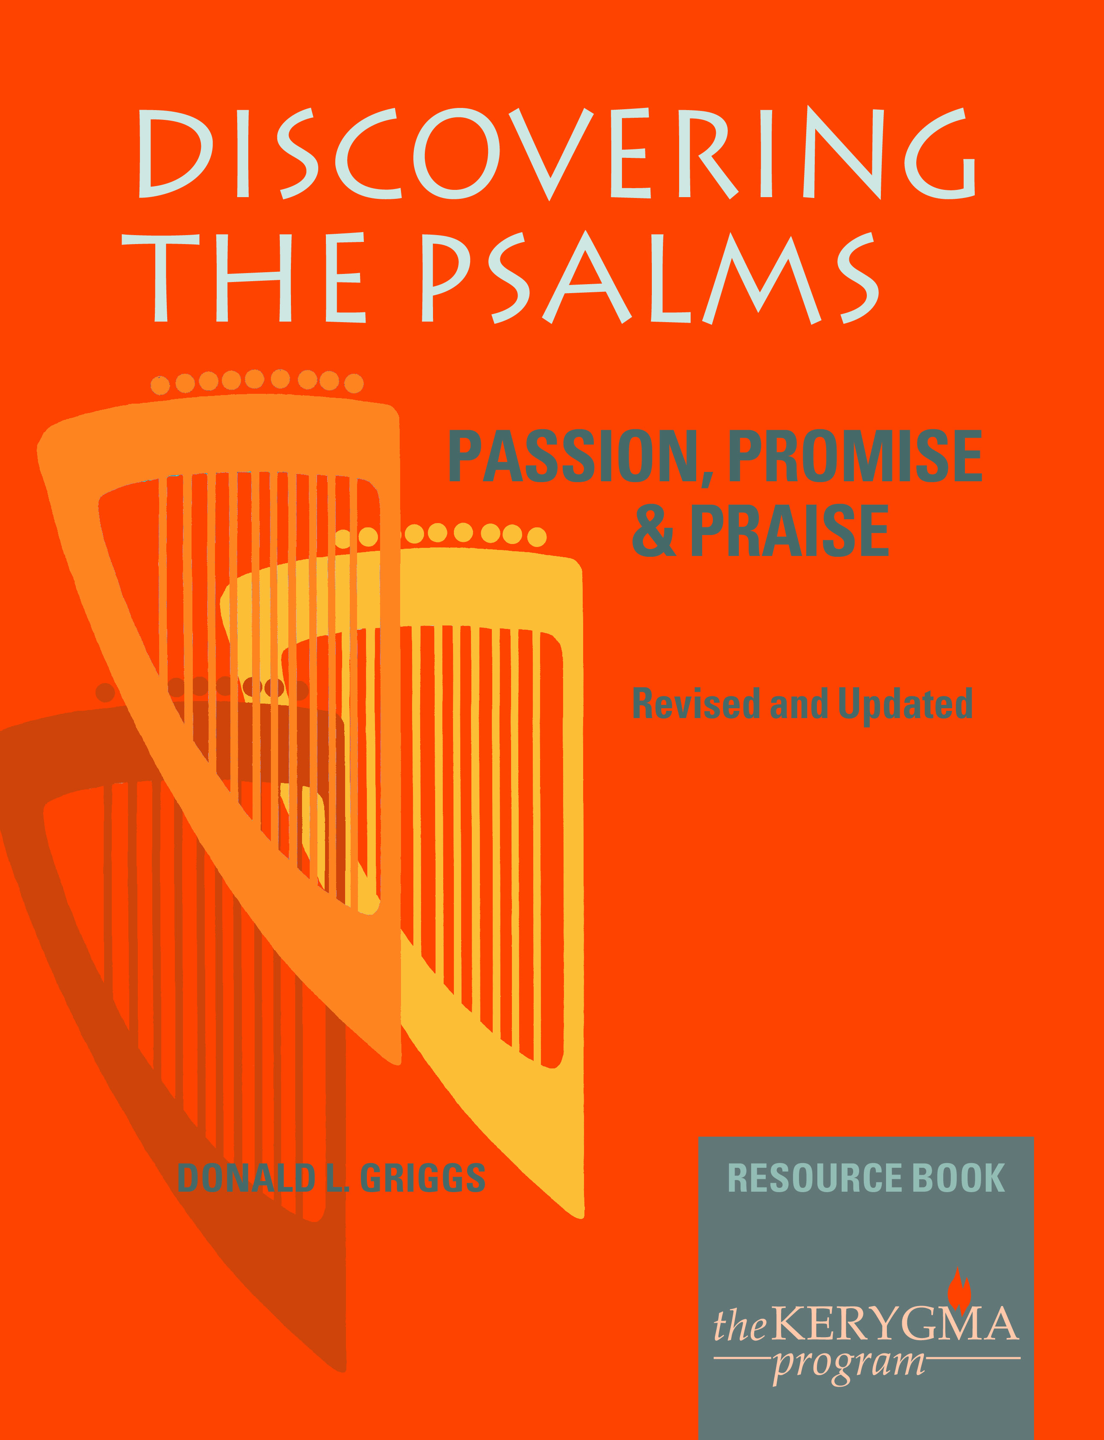

#### EMBARK ON A JOURNEY WITH PSALMS

**Find light for your path, wisdom for your way, and inspiration for your days**

**[ENTER DAY, DATES AND TIME]**

**[ENTER LOCATION OR ROOM]**

**CONTACT [ENTER WHO] OR REGISTER AT [ENTER THE HOW TO]**