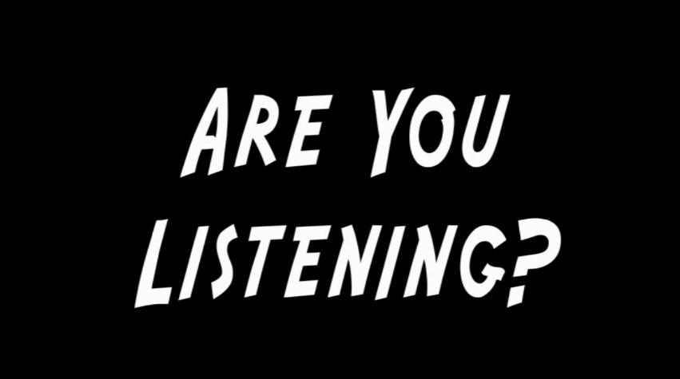

C:\Users\lphillips.KERYGMA\AppData\Local\Microsoft\Windows\Temporary Internet Files\Content.IE5\JWISDUI3\MC900064950[1].wmf





Hearing what Scripture might have said to its first audience allows **their**journey and **ours** to be seen as part of a common scene. Join us as we learn 6 skills so we can hear the message the Bible has for us as Christians today.





**[Enter day, dates and time]**

**[enter location or room]**

**Contact [enter who]**

**or register at [enter the how to]**



