GJ.png

fw.png

gj.png

***It’s an age-old conversation*** . . .

Faith or Works? Gospel or Law?

Join us for an engaging study as we explore these key questions in the life of every Christian.

Two small but mighty studies tackle one of the most contentious issues in theology: what is the role of faith and works when it comes to salvation?

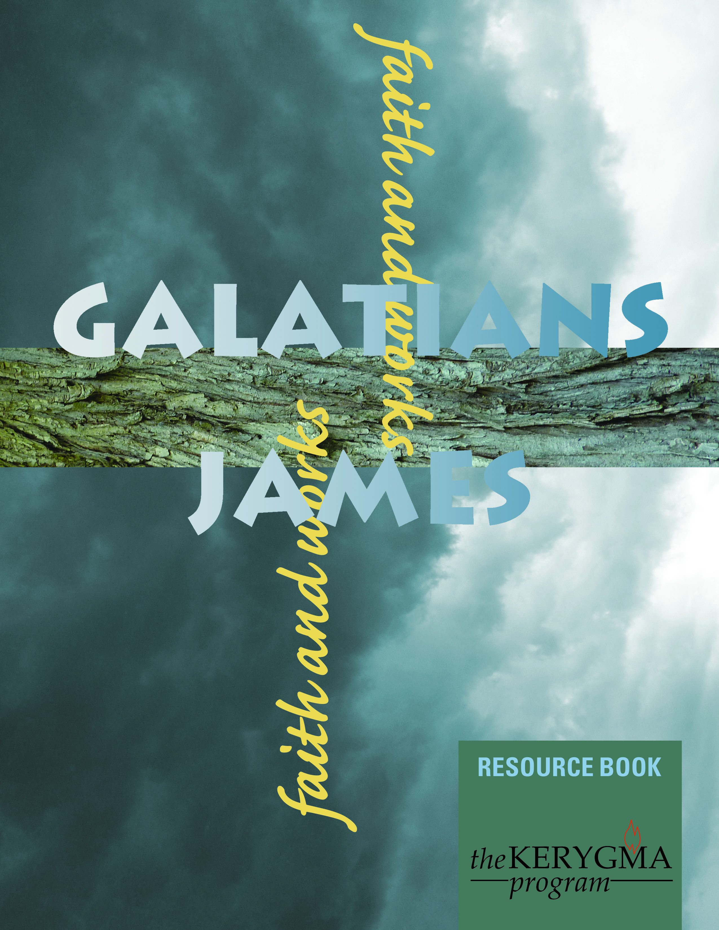

**[ENTER DAY, DATES AND TIME]**

**[ENTER LOCATION OR ROOM]**

**CONTACT [ENTER WHO]**

**OR REGISTER AT [ENTER THE HOW TO]**