PRESS RELEASE

FOR IMMEDIATE RELEASE

For the ultimate in connectivity, accessibility, mobility & security, the revolutionary new AyeGear® J-25 provides a stylish and versatile utility jacket for the seasoned gadget enthusiast.

For further information on AyeGear® products visit: www.ayegear.com

Product video available at www.youtube.com/AyeGear

Press Images of the new AyeGear J25 available at
https://www.dropbox.com/sh/jhrnnak7bolfrlw/4dTNdWAQqI

TRANSFORM
X-RAY
NORMAL
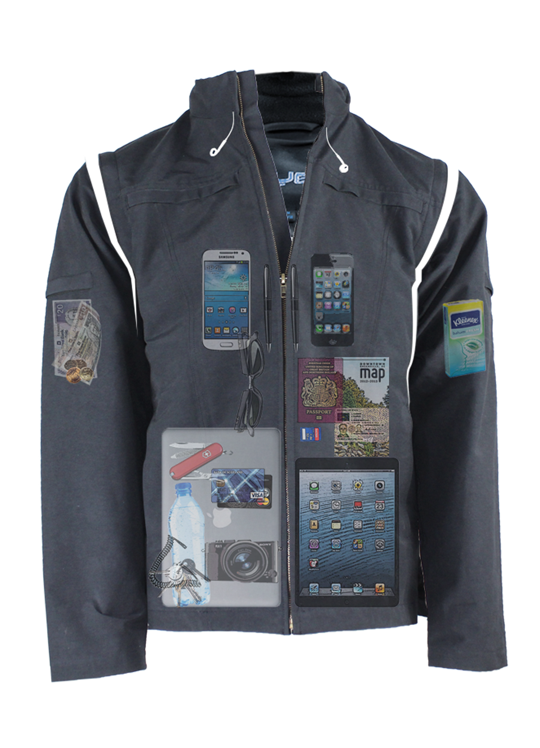
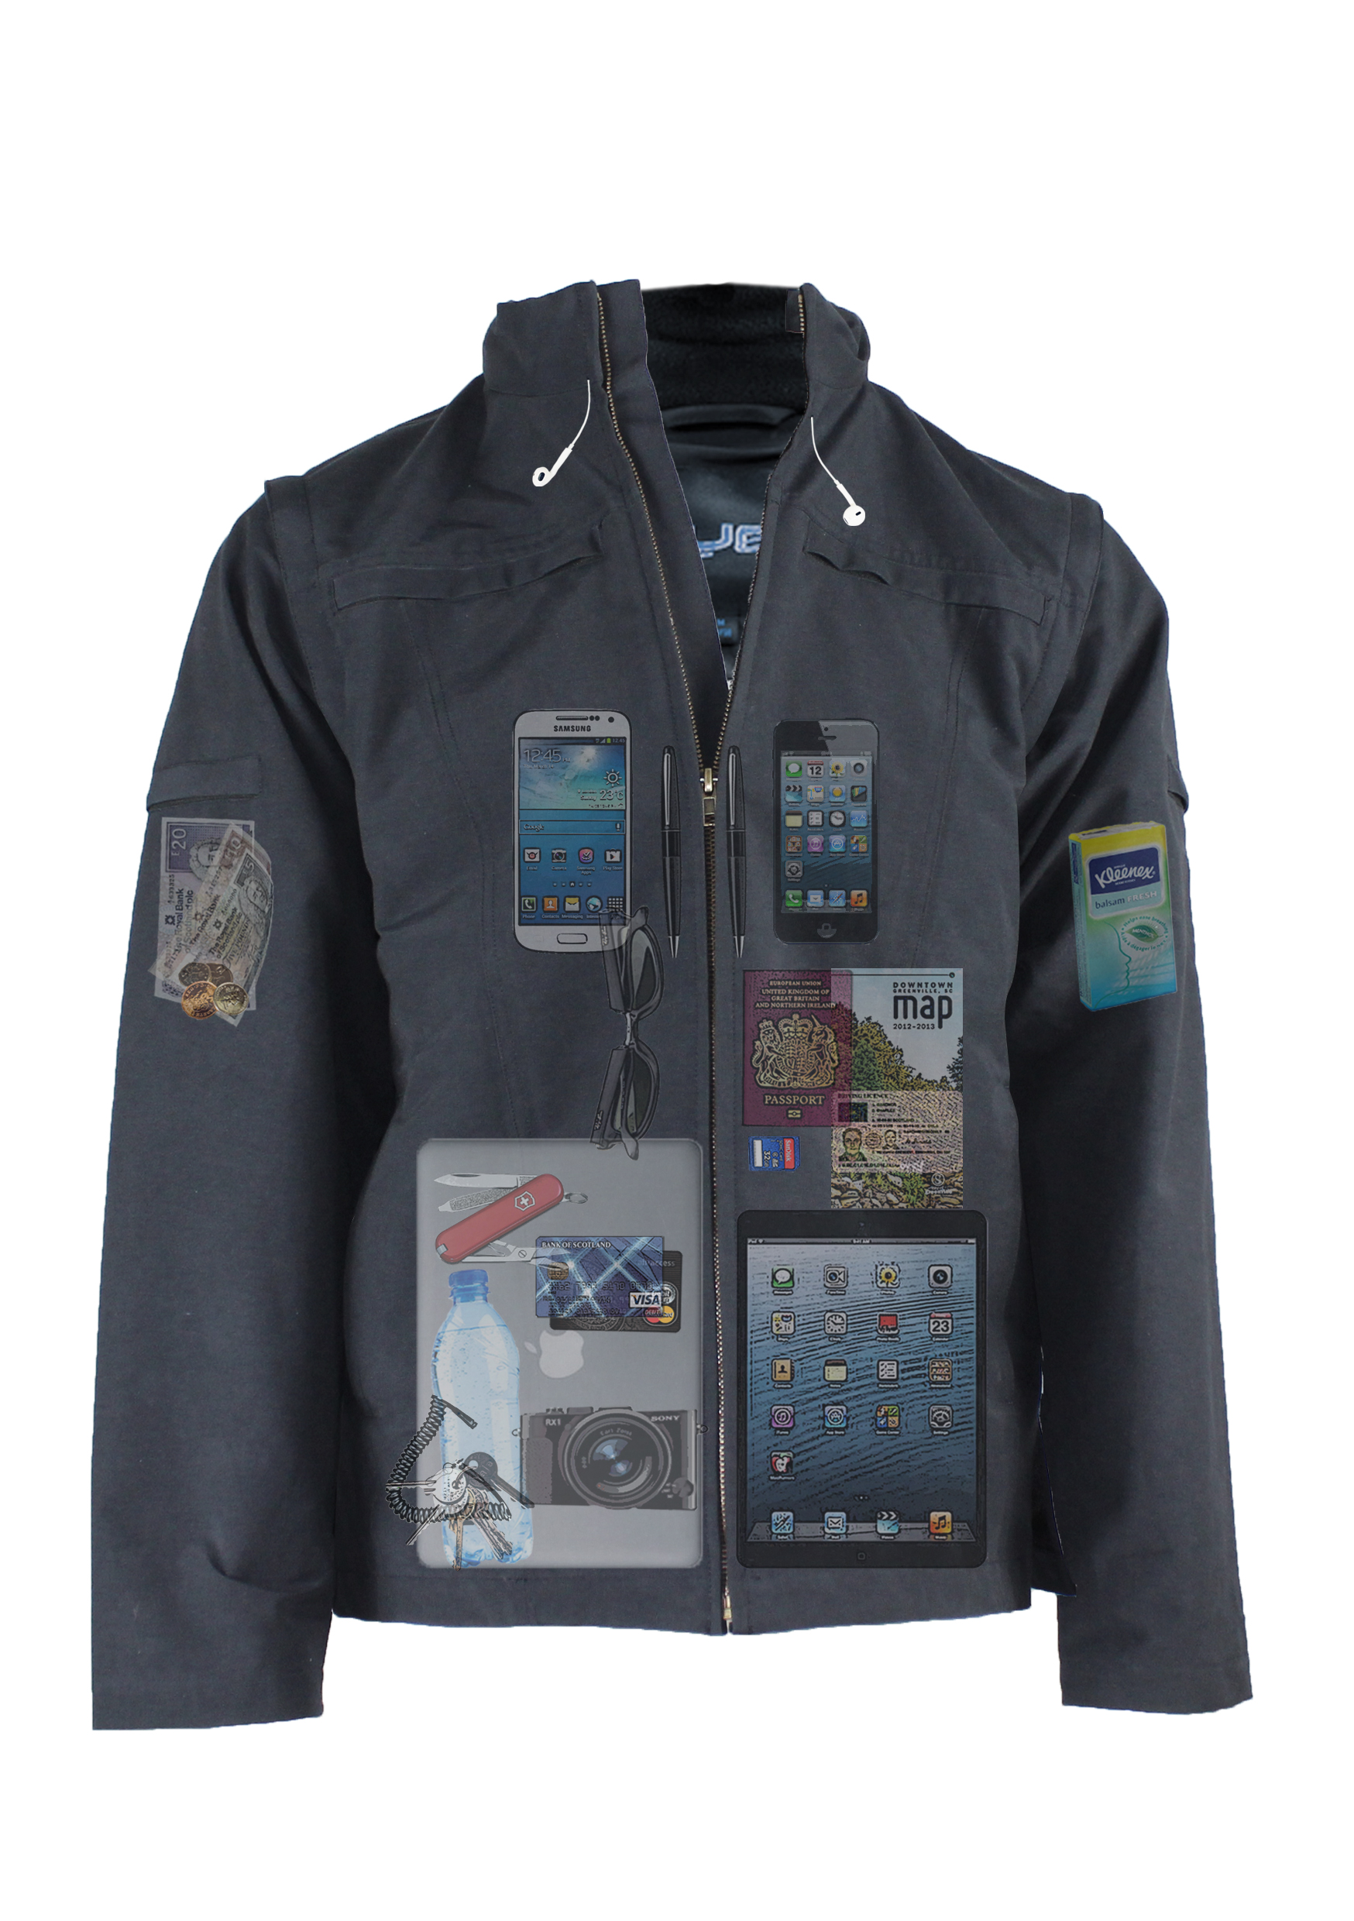
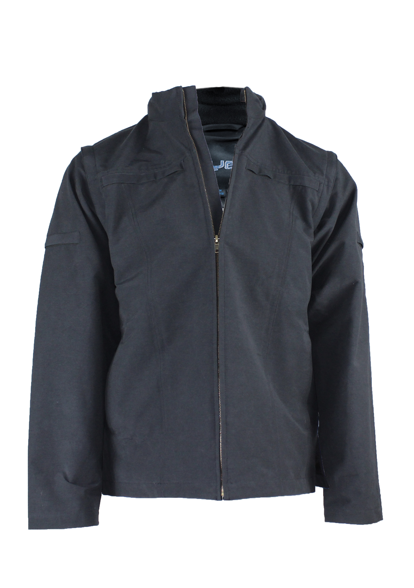
Glasgow, UK, 7th April 2014 – Leading travel apparel manufacturer, AyeGear®, announces today the launch of it’s brand new utility jacket, the AyeGear J-25, which incorporates 25 separate compartments designed to provide wearers with added security and accessibility to all their valuables, gadgets and travel essentials.

Following on from the success of the AyeGear® J-22, the new J-25 has been completely redesigned to incorporate the following features:
- Removable sleeves (Converts the jacket into a cooler feeling vest)
- Concealed hood for added rain protection
- Tougher 3-Layer construction with premium grade zippers
- Breathable & Waterproof Fabric – rating: 800/8000mm
- 25 Specialized compartments designed and labeled for:
      - Tablet x2 (Dual)
      - Laptop up to 15”
      - Smartphone Live x2 (Dual, touchscreen interactive)
      - Credit Cards x4
      - Memory Stick x2
      - SD Cards x2
      - Coins x2
      - Pen x2
      - Passport
      - Personal ID
      - General x6
- Dual access for left or right handed users
- Retractable reel for securing keys
- Internal earphone routing system
- Elasticated strap for drinks bottle
- Designed for minimum bulge and maximum discretion

Features:
Material: Ottoman Fabric (70% Cotton, 30% Nylon)
Sizes: S, M, L, XL, XXL, XXXL
Compartments: 25
Colours: Navy

At the heart of the AyeGear® range is the need to adapt to the growing technology sector and to provide practical solutions to techno savvy travellers who wish to stay connected whilst on the move. This challenge to provide CAMS (connectivity, accessibility, mobility, and security) prompted the company to design a range of quality utility garments for outdoor, sports, travel and leisure use.
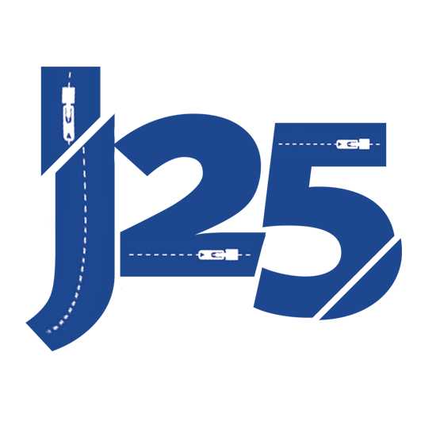
Price and Availability:
Pricing: £139.99 Worldwide Shipping (Free UK delivery)
Pre-order today, ships June 2014

About AyeGear:
AyeGear® was established in Scotland in 2011 with the aim of manufacturing innovative and high quality travelling aids to meet the demands of the modern techno savvy traveller. AyeGear™ has now benefitted from extensive reviews and media publicity and has featured in British Forces News, Gadget Show, Wanderlust, Dubai FM, The Herald, The Journal, Café, Swiss Airlines, App Advice, SBTV, Daily Star and the 9to5Mac Website. The AyeGear® range has also been worn on the set of the Xmen Days of Future Past (2014).

Press Contact:
Dan
press@ayegear.com

