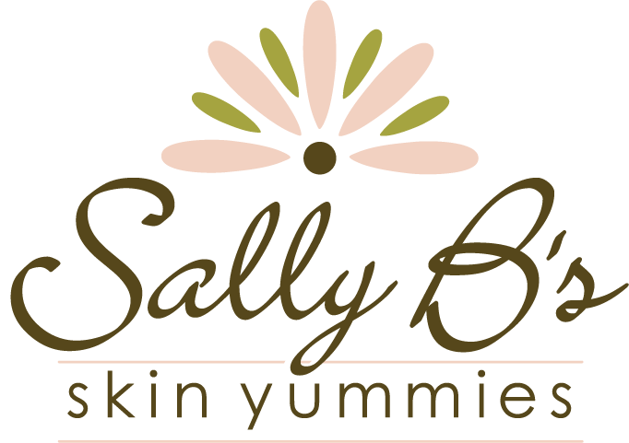

Sally B’s Skin Yummies Unveils New Packaging for Popular B Glossy Lip Gloss

ATLANTA – August 12, 2013 – In their ongoing commitment to sustainability, Sally B’s Skin Yummies unveils new product packaging for their popular B Glossy Lip Gloss that uses less material, thus creates less waste. The new cylindrical plastic tube and mess-free wand applicator packaging holds the same amount of product (7 grams) as the previous hard plastic rectangular tube packaging and is also recyclable, but is lighter weight to make it even more convenient for women on-the-go.

“We make all of our products in small, handmade batches, so we can continue to evolve our products to make them the very best,” explains Sally Larsen, founder of Sally B’s Skin Yummies. “In some cases this means introducing a certified organic ingredient that was not previously not available in the organic form or updating product packaging to be more sustainable for the health of our planet.”

Despite the new look, the B Glossy Lip Gloss formula remains the same – featuring over 95% certified organic ingredients – and is still available in four shades, including the best-selling Ruby’s Red, Every Blonde’s Pink, Primrose, and Copper Penny.

B Glossy Lip Gloss was introduced to the Sally B’s Skin Yummies’ makeup collection in 2009 as a much-needed alternative to the chemically laden lip colors on the market. Instead of the all-too-common lead, artificial coloring, mineral oil, and toxic preservatives, Sally B’s B Glossy Lip Gloss features the highest concentration of organic ingredients possible and other beneficial, good-for-you ingredients like Vitamin E. The formula is Gluten-free and cruelty-free and the result is a shimmery, soothing tint of color for your lips.

“We set out to create a lip gloss that is not only beautiful, but healthy,” says Sally. “Our B Glossy Lip Glossy has no mineral oil or other petroleum derived ingredients, so all the ingredients in our formula are actively improving lip health. Plus, we add a touch of essential oil of peppermint for a soothing and cooling effect when you first apply.”

Sally B’s Skin Yummies B Glossy Lip Gloss in its new, lightweight packaging continues to be available in four shades – Ruby’s Red, Every Blonde’s Pink, Primrose, and Copper Penny – for $18 at www.sallybskinyummies.com.

ABOUT SALLY B’S SKIN YUMMIES

Sally B’s Skin Yummies blends certified organic, natural, and wild-crafted ingredients into nourishing and effective skin care and makeup products that are both people and planet friendly. Developed by hand in Atlanta, Georgia since 2005, Sally B’s Skin Yummies is one of the few Georgia skin care companies dedicated to creating products using the highest concentration of certified organic ingredients possible. Sally B’s Skin Yummies has been named an Innovator by the Environmental Working Group and has received the Leaping Bunny Seal of approval for their dedication to producing cruelty-free products. While sold to a worldwide audience at www.sallybskinyummies.com, Sally B’s Skin Yummies can be found in a number of boutiques, spas, and doctor’s offices across the country, including their flagship location at: 800 Miami Circle, Suite 110, Atlanta, GA 30324. For more information about Sally B’s Skin Yummies or to view their ever-growing collection of skin-loving products, visit: www.sallybskinyummies.com.

###

