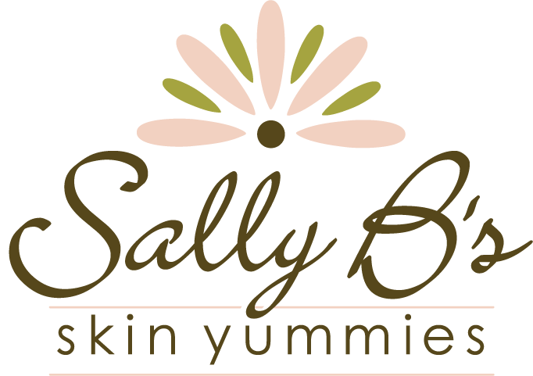

**SALLY B’S SKIN YUMMIES EXPANDS TO NEW BUCKHEAD LOCATION**

*The organic skin care company is now open to the public at 800 Miami Circle, Suite 110*

ATLANTA – July 16, 2013 – Sally B’s Skin Yummies is now open in their new, permanent location, a 2,400 square foot retail space, showroom, and manufacturing area in Buckhead’s Miami Circle. After a bittersweet good bye to their Inman Park location, their home for the last 4 years, Sally B’s Skin Yummies is excited about their new Buckhead neighborhood and expanded kitchen.

The decision to move happened this past spring when owner Sally Larsen got the news that their Inman Park building was being torn down and replaced with a new midrise development. Inman Park’s growth coincided with the company’s growth.

“Over the past year the demand for organic skin care products has risen dramatically and our business is booming here in Atlanta, across the country, and worldwide,” said Sally. “As much as we enjoyed being in Inman Park, we were in fact outgrowing our kitchen.”

Open to the public, the new shop, located at 800 Miami Circle, Suite 110, will have an expanded manufacturing area and retail space, featuring the company’s collection of over 30 organic skin care and makeup products. The space will also be used for product demonstrations, events, and educational programs.

“We are thrilled to finally open the doors to our new space,” said Sally. “Our new Buckhead location will give us a chance to connect with a new audience of women and educate them on the importance of organic and non-toxic skin care, while providing a bigger and better meeting place for our previous customers.”

While a grand opening celebration is set for September, the store is now open Tuesday – Saturday from 11am – 5pm. To view the full collection of Sally B’s Skin Yummies, or for more information, visit: [www.sallybskinyummies.com](http://www.sallybskinyummies.com).

**ABOUT SALLY B’S SKIN YUMMIES**

Sally B’s Skin Yummies blends certified organic, natural, and wild-crafted ingredients into nourishing and effective skin care and makeup products that are both people and planet friendly. Developed by hand in Atlanta, Georgia since 2005, Sally B’s Skin Yummies is one of the few Georgia skin care companies dedicated to creating products using the highest concentration of certified organic ingredients possible. Sally B’s Skin Yummies has been named an Innovator by the Environmental Working Group and has received the Leaping Bunny Seal of approval for their dedication to producing cruelty-free products. While sold to a worldwide audience at [www.sallybskinyummies.com](http://www.sallybskinyummies.com), Sally B’s Skin Yummies can be found in a number of boutiques, spas, and doctor’s offices across the country, including their flagship location at: 800 Miami Circle, Suite 110, Atlanta, GA 30324. For more information about Sally B’s Skin Yummies or to view their ever-growing collection of skin-loving products, visit: [www.sallybskinyummies.com](http://www.sallybskinyummies.com).

###